
National Consumer Agency

Market Research Findings:
Consumer Switching Behaviour

February 2012
Table of Contents
1 Introduction and Methodology 4
2 Consumer Switching Behaviour 6
3 Key Points 13

Table of Figures
Figure 1 Extent of Switching Providers in the Past 12 Months 6
Figure 2 Extent of Switching Providers in Past 5 Years and Resulting Savings - Primary 8
Figure 3 Extent of Switching Providers in Past 5 Years and Resulting Savings - Secondary 8
Figure 4 Average Amount Saved due to Switching Provider 9
Figure 5 Reasons for Not Switching Provider Within Past Year - I 10
Figure 6 Reasons for Not Switching Provider Within Past Year - II 10
Figure 7 Reasons for Not Switching Provider Within Past Year - III 11
Figure 8 Experience of the Switching Process 11
Figure 9 Service Received with New Provider 12

Table of Tables
Table 1 Previous Waves of Market Research 4

Introduction and Methodology
In November 2011 Amárach Research continued the programme of consumer research conducted on behalf of the National Consumer Agency, the purpose being to monitor, analyse and record patterns of consumer behaviour and experiences in Ireland.

A key feature of how this market research is used, involves the comparison of data collected in previous iterations (see Table 1 below) with the current consumer landscape. This comparison provides a valuable time-series.
- Previous Waves of Market Research

Survey | Conducted
Benchmark | November/December 2007
Wave 1 | August 2008
Wave 2 | November/December 2008
Wave 3 | May/June 2009
Wave 4 | November/December 2009
Wave 5 | June 2010
Wave 6 | November/December 2010
Wave 7 | May/June 2011

The latest research, consistent with previous surveys, was conducted by means of face-to-face interviewing with 1,000 people between the ages of 15 to 74. To ensure that the data is nationally representative, quotas were applied on the basis of age, gender, social class and region. Interviews were conducted over a four-week period in November 2011.

The Agency’s programme of market research explores a wide range of consumer behaviour and experiences in Ireland and the current wave includes:
- The level of consumer empowerment and awareness of consumer rights
- Consumer behaviour in relation to shopping and pricing
- Household budgeting and financial planning
- Trends in switching goods/service providers and
- Consumer experiences with customer service

The findings of the market research are reported through a number releases. This report, the third release in the current wave, details the findings relating to Irish consumers’ experiences and attitudes with regard to switching products/services.

PowerPoint versions of the slides in this report, in addition to details of all of the Agency’s research activities, are available at http://www.nca.ie/eng/Research_Zone/Reports/.

Consumer Switching Behaviour
Figure 1 shows the extent to which consumers have switched product or service providers within the past 12 months. Results are presented for 18 separate categories and are ranked into groups, in order of the current rate of switching. Results of the previous two waves are also shown (this is the case throughout the report, where data is comparable).

Car insurance recorded the highest level of switching in the past year as 17% of all holders or purchasers of policies had switched their provider. This figure is down 5% since the previous iteration of research conducted in May/June 2011. The second most commonly switched category was mobile telephone providers unchanged at 12%. 12% of consumers switched where they do the main grocery shop, down 5%. A similar proportion, 10% have changed provider for top-up grocery shop, 11% changed electricity supply (down 6%) and 12% have changed broadband/internet access provider.

- Extent of Switching Providers in the Past 12 Months
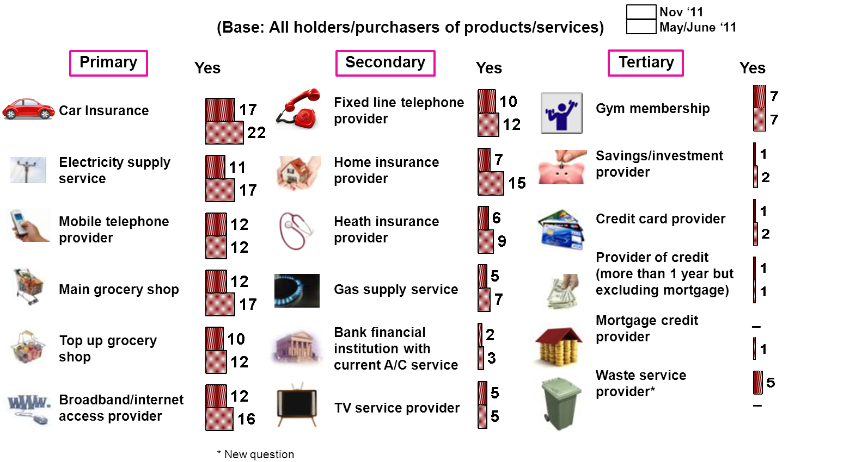
Financial products, in line with previous rounds of research, remain the least switched categories.

Of the 18 categories surveyed, 17 have comparable data from May/June 2011 and of these 17 categories, four remain unchanged in terms of the number of consumers who have switched in the past 12 months and 13 sectors have experienced a decline in the numbers switching. Across all categories 38% of consumers have switched provider in at least one category surveyed, a decrease of 5% from May/June 2011, but up 1% from the same time last year.

Figures 2 and 3 illustrate the results, across the 18 categories, in relation to consumers switching in the past year as well as multiple switching, i.e. having switched more than once in the past five years. Information is also displayed with regard to the number of consumers who reported that they saved money as a result of switching in the previous 12 months.

From Figure 2, just over 1 in 5 (21%) have switched car insurance provider more than once within the past five years with a similar proportion of consumers, 20%, switching their mobile phone provider more than once. The next sectors with the highest incidence of repeat switching are main grocery shop (17%), broadband internet access (16%), electricity supply service (14%), fixed/landline telephone (14%) and top up grocery shop (14%).

Overall, from data not shown, across all categories 85% of consumers who had switched service providers in the last twelve months said they had saved money as a result. 95% of consumers who switched car insurance stated that they saved money. Over 9 in 10 (91%) consumers who switched home insurance stated that they saved money. As can be seen from Figure 2 the percentage who indicated that they saved money by switching is high across these sectors, with the lowest reported being 55% for the top up grocery shop category.

- Extent of Switching Providers in Past 5 Years and Resulting Savings - Primary
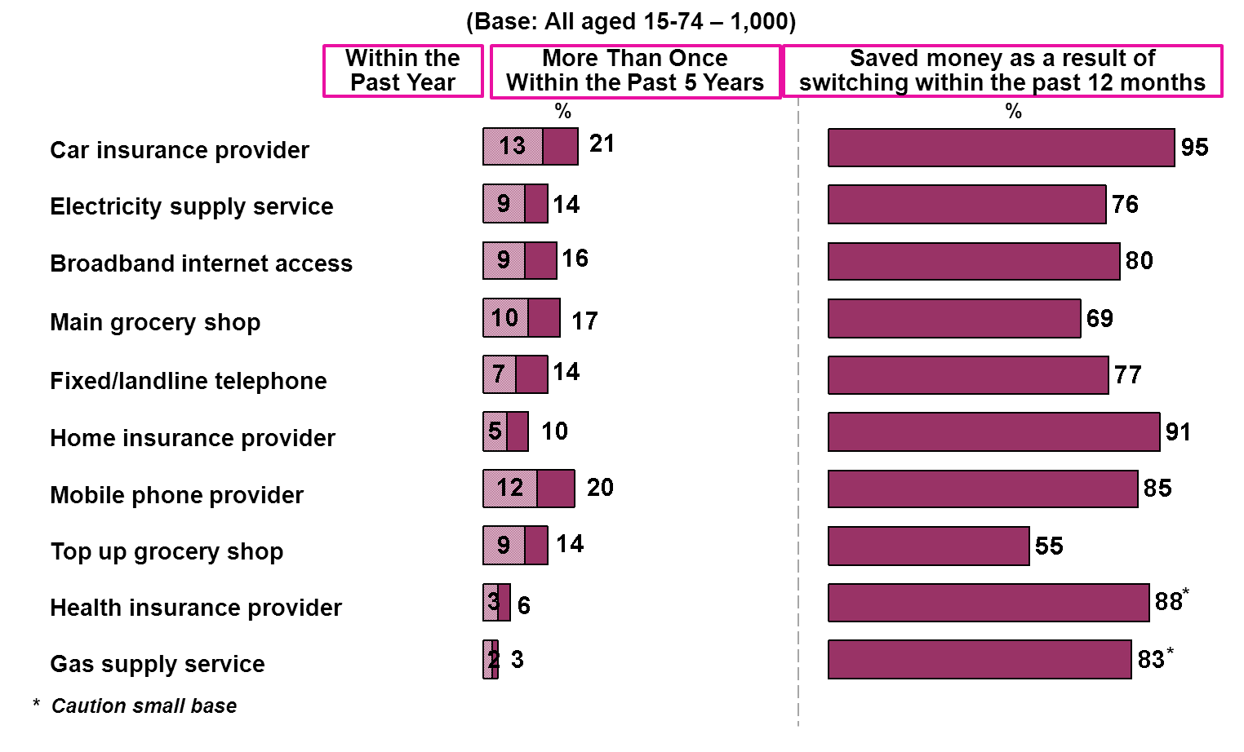

- Extent of Switching Providers in Past 5 Years and Resulting Savings - Secondary
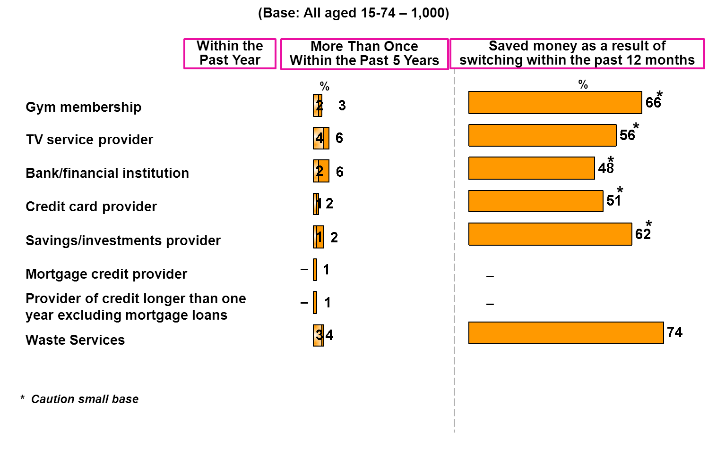
Figure 4 shows how much on average consumers who switched home and car insurance stated they saved as a result. On average consumers stated that they saved €102 by switching car insurance provider and €84 by switching home insurance provider.

- Average Amount Saved due to Switching Provider
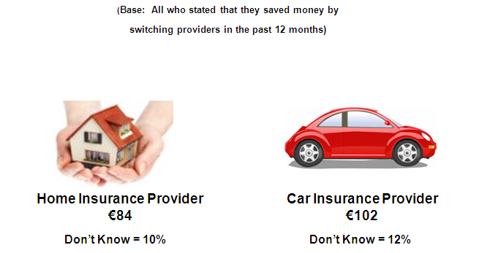

As shown in Figures 5, 6 and 7 across all the sectors surveyed the main reason given for not switching product/service provider is due to satisfaction with the quality/level of service with the current provider, followed by current supplier offers the best value for money.

Most consumers found it too difficult to determine who provides the best value for money in the bank category (10%), consumers unable to switch due to limitations put in place by providers was highest amongst mortgage credit institutions (12%). Mortgage credit providers was also the highest category where consumers felt the time and money needed to switch outweigh the benefits (8%). In the waste services category, no convenient alternative provider was given as the reason for not switching by 7%.

- Reasons for Not Switching Provider Within Past Year - I

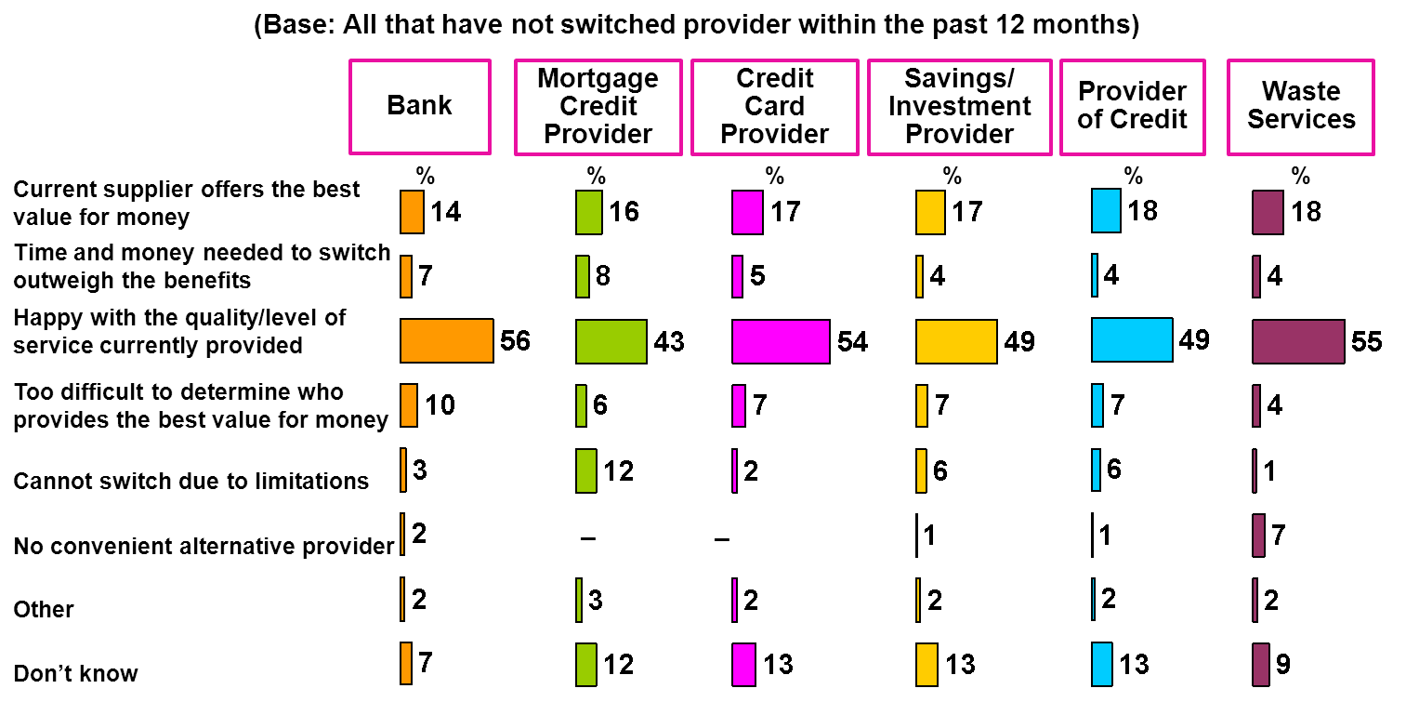

- Reasons for Not Switching Provider Within Past Year - II

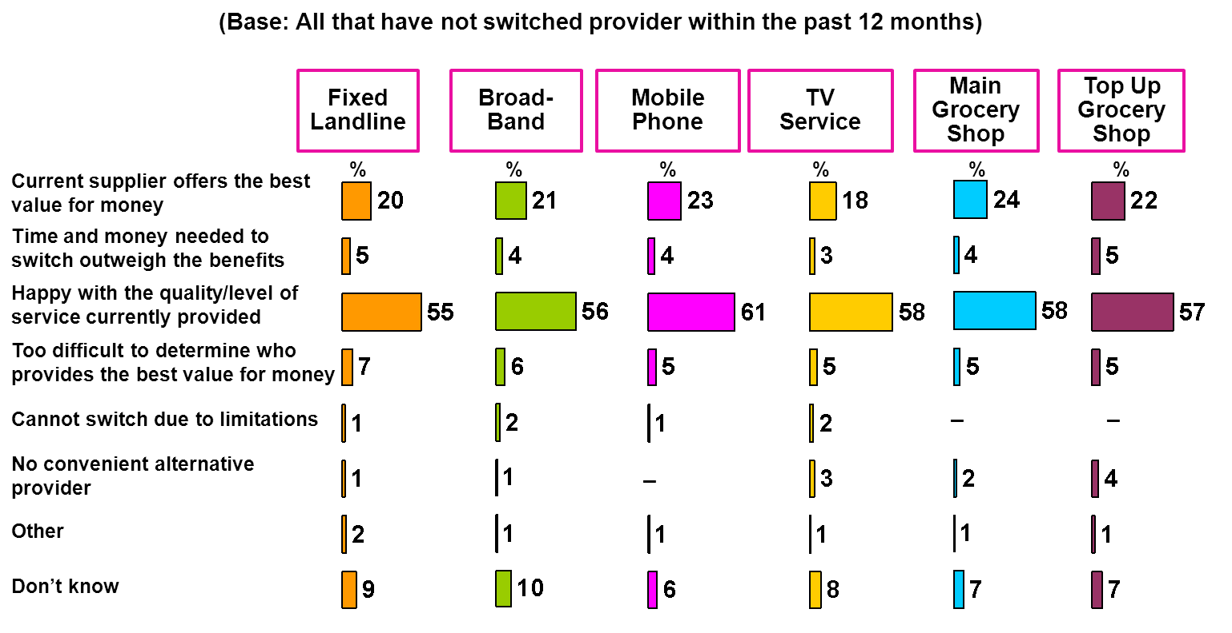

- Reasons for Not Switching Provider Within Past Year - III
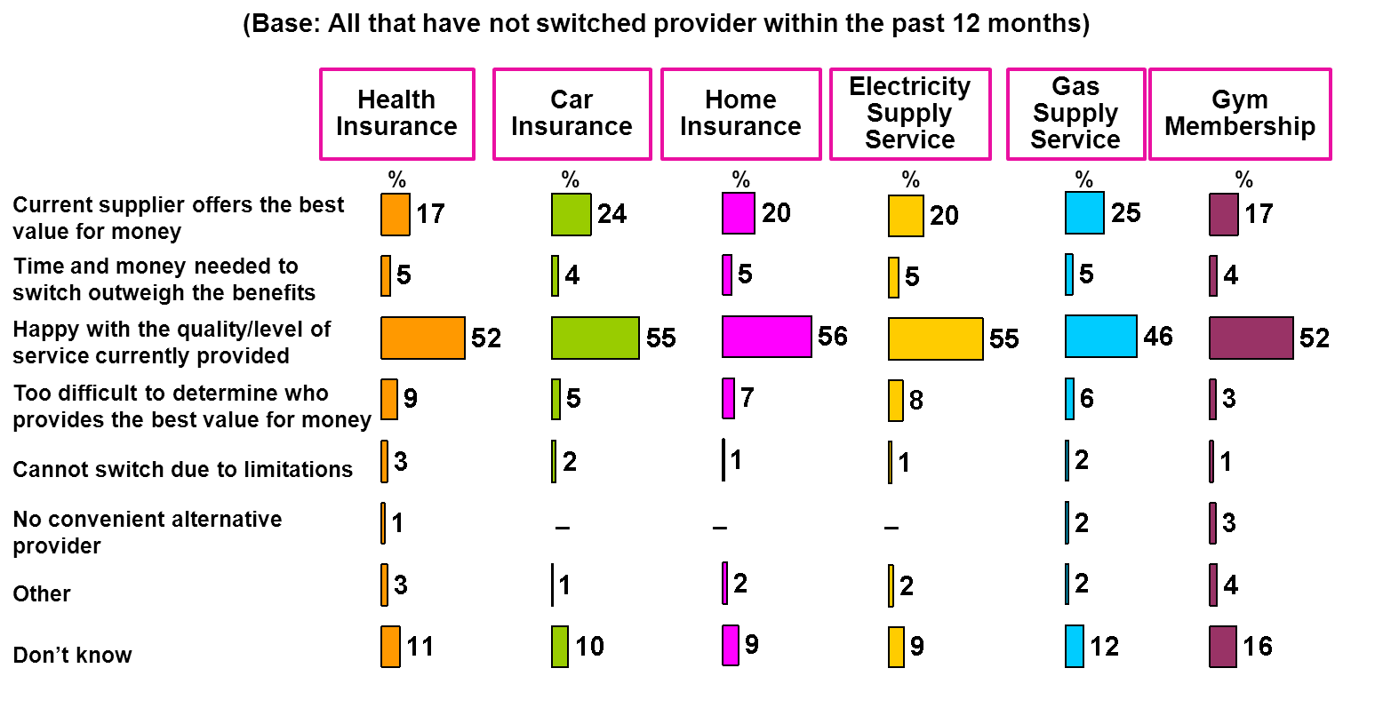

Figure 8 illustrates consumers’ experience of the switching process. The number finding the process easy remains high at 84% and over half (52%) found the switching process very easy. Just 4% found the process somewhat difficult.
- Experience of the Switching Process
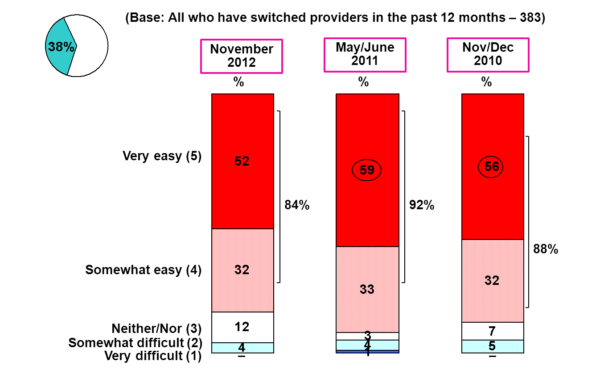

Half of the consumers who have switched in the past year (50%) have found the new service they receive to be better, with just 2% reporting that service received from new provider is worse.

- Service Received with New Provider
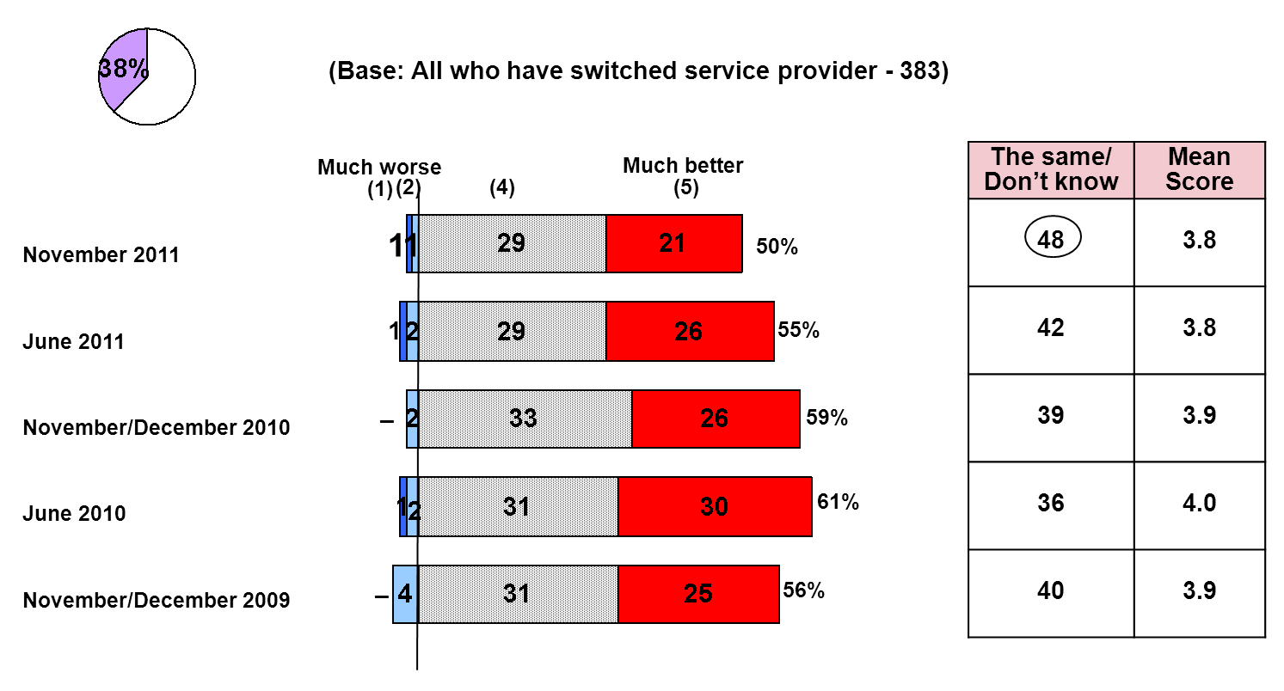

Key Points
In November 2011 the National Consumer Agency continued its programme of consumer research, the purpose being to monitor, analyse and record patterns of consumer behaviour and experiences in Ireland. The research, consistent with previous surveys, was conducted by means of face-to-face interviewing with a nationally representative sample of 1,000 people between the ages of 15 to 74. This report presented the results relating to Irish consumers’ experience and attitudes with regard to consumer switching behaviour.

The key findings are:
- Overall 85% of Irish consumers who had switched a product or service provider in the past 12 months said they had saved money as a result. 95% of those who switched car insurance stated that they have saved money by doing so. The average amount saved was €102. 91% saved by switching house insurance where an average of €84 was saved.
- 38% of consumers have switched at least one product or service provider in the previous 12 months, a decrease of 5% from May/June 2011 but up 1% since Nov/Dec 2010. Consumers are most likely to have switched car insurance (17%), mobile phone provider (12%), broadband/internet access provider and main grocery shop (12%).
- Across all categories, the main reason given for not switching product/service provider is due to “satisfaction with the quality/level of service with the current provider”, followed by “current supplier offers the best value for money”.
- 52% of consumers found the switching process very easy and overall 84% stated that they found the process easy. Just 4% reported that they found the switching process difficult.
- 50% of those who have switched in the past year have found the new service they receive to be better. Just 2% reported that service received from new provider is worse with 48% saying that it was the same or don’t know.

The percentage changes mentioned in this report refer to an increase or decease in percentage points.

