

National Consumer Agency

Market Research Findings:
Consumer Switching Behaviour

September 2011
Table of Contents
1 Introduction and Methodology 4
2 Consumer Switching Behaviour 6
3 Key Points 12

Table of Figures
Figure 1 Extent of Switching Providers in the past 12 months 6
Figure 2 Saved Money due to Switching Provider 7
Figure 3 Extent of Switching Providers in past 3 years and the level of Multiple Switching - Primary 8
Figure 4 Reasons for Not Switching Provider Within Past 3 Years – I 9
Figure 5 Reasons for Not Switching Provider Within Past 3 Years – II 9
Figure 6 Experience of the Switching Process 10
Figure 7 Service Received with New Provider 11
Figure 8 Future Likelihood of Switching Providers 11

Table of Tables
Table 1 Previous Waves of Market Research 4

Introduction and Methodology
In May and June 2011 Amárach Research continued the programme of consumer research conducted by the National Consumer Agency to monitor, record and analyse patterns of consumer behaviour and experiences in Ireland.

A key feature of the research is comparison of data collected in previous “waves” of market research (see Table 1 below), with the current consumer landscape. This comparison provides a valuable time-series. Details of the Agency’s comparable market research are as follows:

- Previous Waves of Market Research

Survey | Conducted
Benchmark | November/December 2007
Wave 1 | August 2008
Wave 2 | November/December 2008
Wave 3 | May/June 2009
Wave 4 | November/December 2009
Wave 5 | June 2010
Wave 6 | November/December 2010

The research, consistent with previous surveys, was conducted by means of face-to-face interviewing with 1,000 people between the ages of 15 to 74. To ensure that the data is nationally representative, quotas were applied on the basis of age, gender, social class and region. Interviews were conducted over a four-week period in May and June 2011.

The Agency’s programme of market research explores a wide range of consumer behaviour and experiences in Ireland, including:
- The level of consumer empowerment, awareness of consumer rights and the propensity to complain
- Consumer behaviour with regard to shopping and pricing
- Consumers’ response to the recession and household budgeting
- Trends in switching goods/service providers and
- Consumer experience with regard to direct selling

The findings of the market research are compiled across a number of volumes. This report, the third release of the current series, details the results relating to Irish consumers’ experiences and attitudes with regard to consumer switching behaviour.

PowerPoint versions of the slides in this report, in addition to details of all of the Agency’s research activities, are available from
http://www.nca.ie/eng/Research_Zone/Reports/.

Consumer Switching Behaviour
Figure 1 shows the extent to which consumers have switched product or service providers within the past 12 months. Results are presented for 17 expenditure categories and are ranked into groups, depending on the current rate of switching. Results of previous waves are also shown (this is the case throughout the report, where data is comparable).

The category where people have switched most frequently is car insurance with 22% of consumers holding or purchasing a policy switching provider. 17% of consumers have switched their electricity supplier and main grocery shop in the previous 12 months. In the last year just over 1 in 10 have switched mobile telephone provider (12%) and with 16% switching broadband/internet access provider. Consumers are least likely to have switched financial product providers be it savings or investment (2%), credit card (2%), credit (1%) or mortgage (1%).

- Extent of Switching Providers in the past 12 months
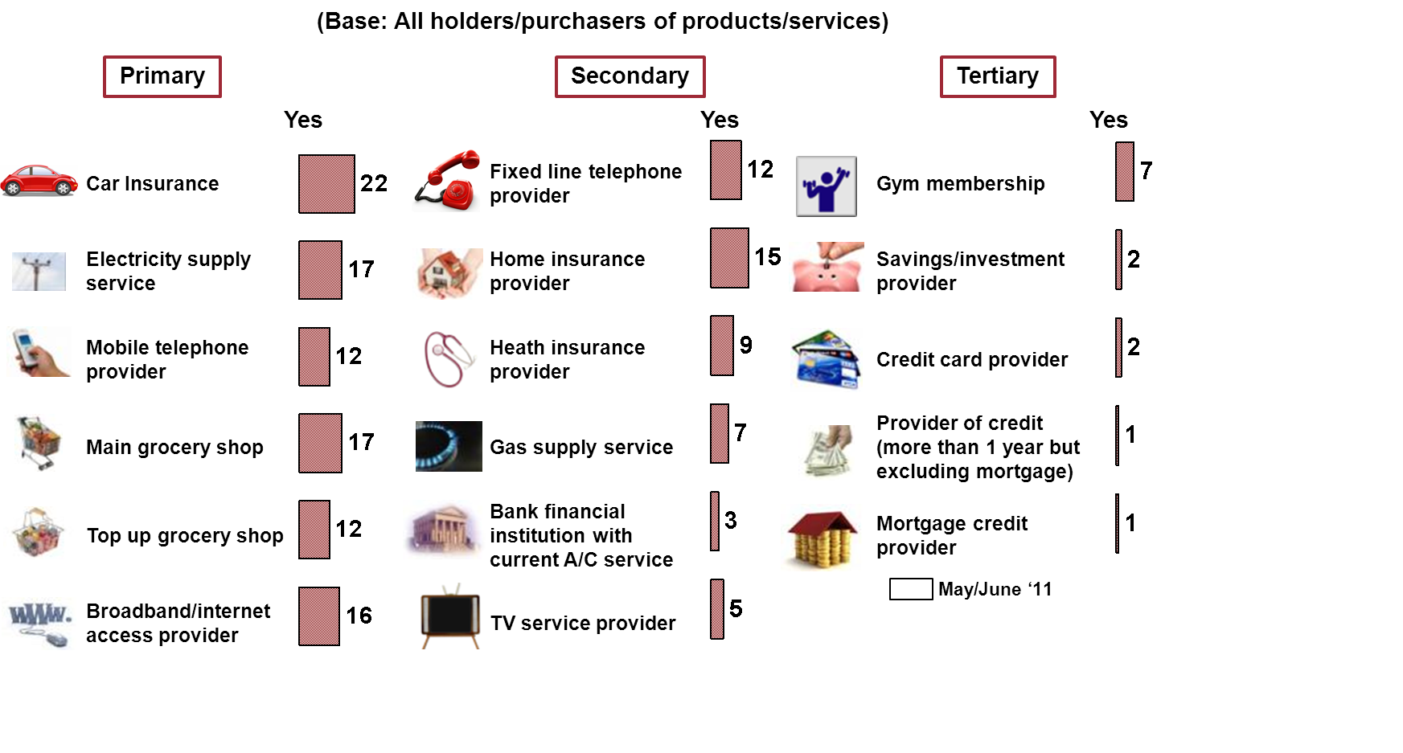

Overall the amount of switching is on the increase since the previous wave. Across all 17 categories surveyed, 43% of consumers have switched provider in at least one category, up 6% from the previous wave of research.

As can be seen in Figure 2, a large majority of consumers have saved money by switching insurance providers, 88% for car insurance and 86% for home insurance, an increase of 11% and 9% respectively from November/December 2010 research.

76% of consumers have saved money by switching main grocery shop and by switching mobile telephone provider in the last year. Over 7 in 10 (72%) have saved money by switching fixed/landline telephone provider and broadband/internet access provider and 71% saved money by switching electricity provider.

Overall across all categories 79% of consumers, who had switched service providers in the last twelve months, said they had saved money as a result.

- Saved Money due to Switching Provider

Figure 3 illustrates the level of switching over the past three years including the incidence of multiple switching. Overall 53% of consumers, from detailed data not shown, have switched at least one product or service provider over the past three years. Almost 1 in 4 (24%) consumers have switched car insurance provider in the past 3 years and of these 2 in 5 (41%) have switched more than once. 21% of consumers have switched electricity supply provider in the past three years with 17% of those switching more than once.

Of those that have switched top up grocery shop within the past 3 years; almost 3 in 5 (57%) have switched more than once and almost 1 in 2 (49%) of those who switched main grocery shop in the past three years have switched more than once.

- Extent of Switching Providers in past 3 years and the level of Multiple Switching - Primary
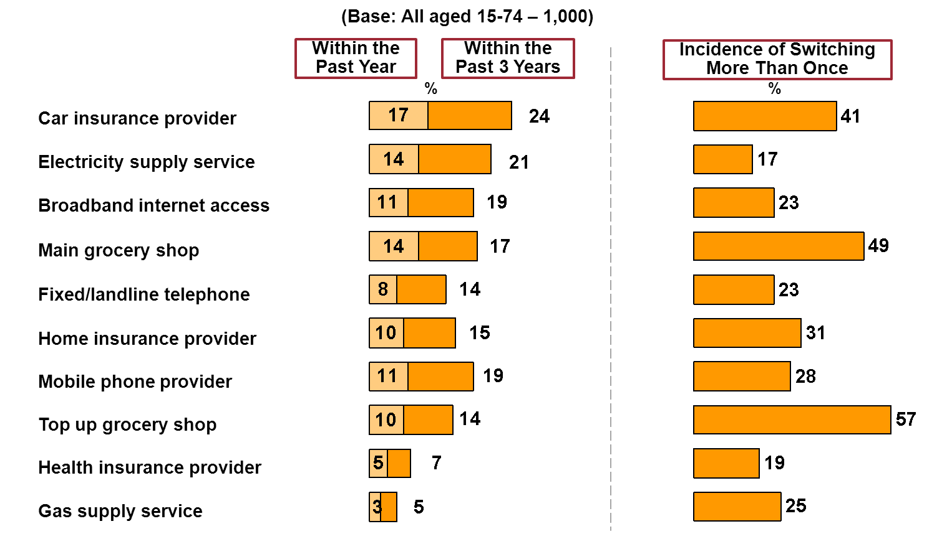

Across all the sectors surveyed the main reason given for not switching product/service provider is due to satisfaction with the current provider, as shown in Figures 4 and 5. This may indicate that not all consumers are aware of the benefits of switching.
- Reasons for Not Switching Provider Within Past 3 Years – I

- Reasons for Not Switching Provider Within Past 3 Years – II

Consumers’ experience of the switching process is illustrated in Figure 6. Over 9 in 10 (92%) of those who switched provider in the past year found the process easy, with 3 in 5 (59%) finding it a very easy process. Only 5% of those who switched found the experience difficult.

- Experience of the Switching Process

From Figure 7, it can be seen that 55% of consumers who have switched service provider feel that they are receiving a better service, a slight decrease of 4% from the November/December 2010 research.

- Service Received with New Provider

Figure 8 shows the likelihood of respondents switching providers in the next year across a wide range of categories. Insurance providers are again top of the list with 1 in 5 (19%) considering a switch for car insurance and over 1 in 10 (12%) considering changing their home insurance provider. The areas were people are least likely to switch are savings and investment providers (2%), providers of credit (1%) and mortgage providers (1%).

- Future Likelihood of Switching Providers

Key Points
In May and June 2011 the National Consumer Agency continued its programme of consumer research with a view to monitoring, analysing and recording patterns of consumer behaviour and experiences in Ireland. The research, consistent with previous surveys, was conducted by means of face-to-face interviewing with a nationally representative sample of 1,000 people between the ages of 15 to 74. This report presented the results relating to Irish consumers’ switching behaviour. The key findings are as follows:
- In the past year consumers are most likely to have switched providers for car insurance (22%), electricity (17%) and main grocery shop (17%).
- Overall 79% of Irish consumers who had switched a product or service provider in the past 12 months said they had saved money as a result. 88% of consumers saved money by switching providers for car insurance, and 86% saved after switching home insurance.
- 24% of consumers have switched car insurance provider in the past three years and of these 2 in 5 (41%) have switched more than once. 21% of consumers have switched electricity supply provider in the past three years with 17% of those switching more than once.
- Over 9 in 10 (92%) found the switching process easy opposed to the 5% who found it difficult. 55% assert they now receive a better service with their new provider.
- Almost 1 in 5 stated they are likely to switch car insurance (19%) within the next 12 months. Approximately 1 in 10 are likely to switch home insurance (12%), mobile phone (10%), top-up grocery (10%) and main grocery (11%) and electricity supply service (9%) provider.

