
National Consumer Agency

Market Research Findings:
Consumer Empowerment and Customer Service

March 2012
Table of Contents
1 Introduction and Methodology 4
2 Consumer Rights Awareness Levels 6
3 Customer Service 9
4 Key Points 13

Table of Figures
Figure 1 Confidence About Rights as a Consumer 6
Figure 2 Knowledge About Consumer Rights 7
Figure 3 Protected Regarding Consumer Rights 7
Figure 4 Summary of Empowerment 8
Figure 5 Experience with Customer Service - I 9
Figure 6 Experience with Customer Service - II 10
Figure 7 Satisfaction with Customer Service - I 10
Figure 8 Satisfaction with Customer Service - II 11
Figure 9 Likely Action as a result of Good or Bad Customer Service 12

Table of Tables
Table 1 Previous Waves of Market Research 4

Introduction and Methodology
In November 2011 Amárach Research continued the programme of consumer research conducted on behalf of the National Consumer Agency, the purpose being to monitor, analyse and record patterns of consumer behaviour and experiences in Ireland.

A key feature of how this market research is used, involves the comparison of data collected in previous iterations (see Table 1 below) with the current consumer landscape. This comparison provides a valuable time-series.
- Previous Waves of Market Research

Survey | Conducted
Benchmark | November/December 2007
Wave 1 | August 2008
Wave 2 | November/December 2008
Wave 3 | May/June 2009
Wave 4 | November/December 2009
Wave 5 | June 2010
Wave 6 | November/December 2010
Wave 7 | May/June 2011

The latest research, consistent with previous surveys, was conducted by means of face-to-face interviewing with 1,000 people between the ages of 15 to 74. To ensure that the data is nationally representative, quotas were applied on the basis of age, gender, social class and region. Interviews were conducted over a four-week period in November 2011.

The Agency’s programme of market research explores a wide range of consumer behaviour and experiences in Ireland and the current wave includes:
- The level of consumer empowerment and awareness of consumer rights
- Consumer behaviour in relation to shopping and pricing
- Household budgeting and financial planning
- Trends in switching goods/service providers and
- Consumer experiences with customer service

The findings of the market research are reported through a number of releases. This report details the results relating to Irish consumers’ experiences and attitudes with regard to consumer empowerment (Section 2) and consumers’ experiences with customer service (Section 3).

PowerPoint versions of the slides in this report, in addition to details of all of the Agency’s research activities, are available at http://www.nca.ie/eng/Research_Zone/Reports/.

Consumer Rights Awareness Levels
Figure 1 presents consumers’ stated levels of confidence about their rights when buying goods and services. Data is presented for eight comparable iterations of research.

The latest results show that over 3 in 4 (77%) consumers feel confident in their consumer rights; this has dropped 1% since May/June 2011 which was a record high of 78%. 11% of consumers do not feel confident in their consumer rights. This has increased 1% from its record low of 10% recorded in the previous wave.

- Confidence About Rights as a Consumer
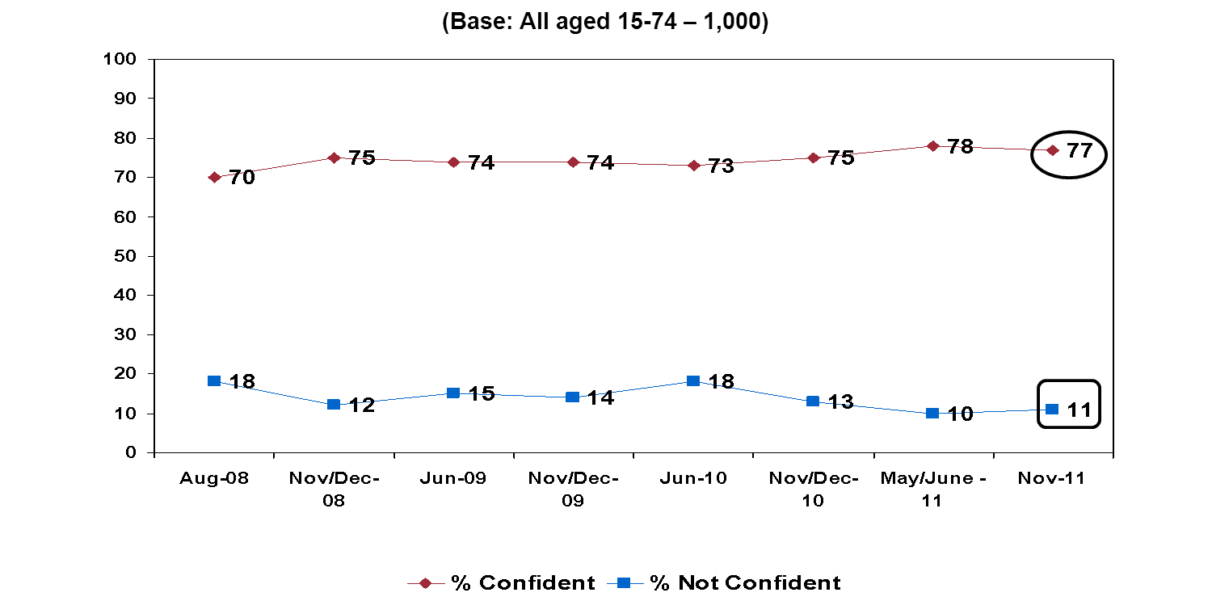

Figure 2 examines respondents declared knowledge of their consumer rights. Nearly 3 in 4 consumers (72%) claim to be knowledgeable about their consumer rights, the highest level to date. The proportion of consumers stating that they are not knowledgeable has reached its lowest level in the course of this series now standing at 14%, down 3% since the last time of asking in May/June 2011.

- Knowledge About Consumer Rights
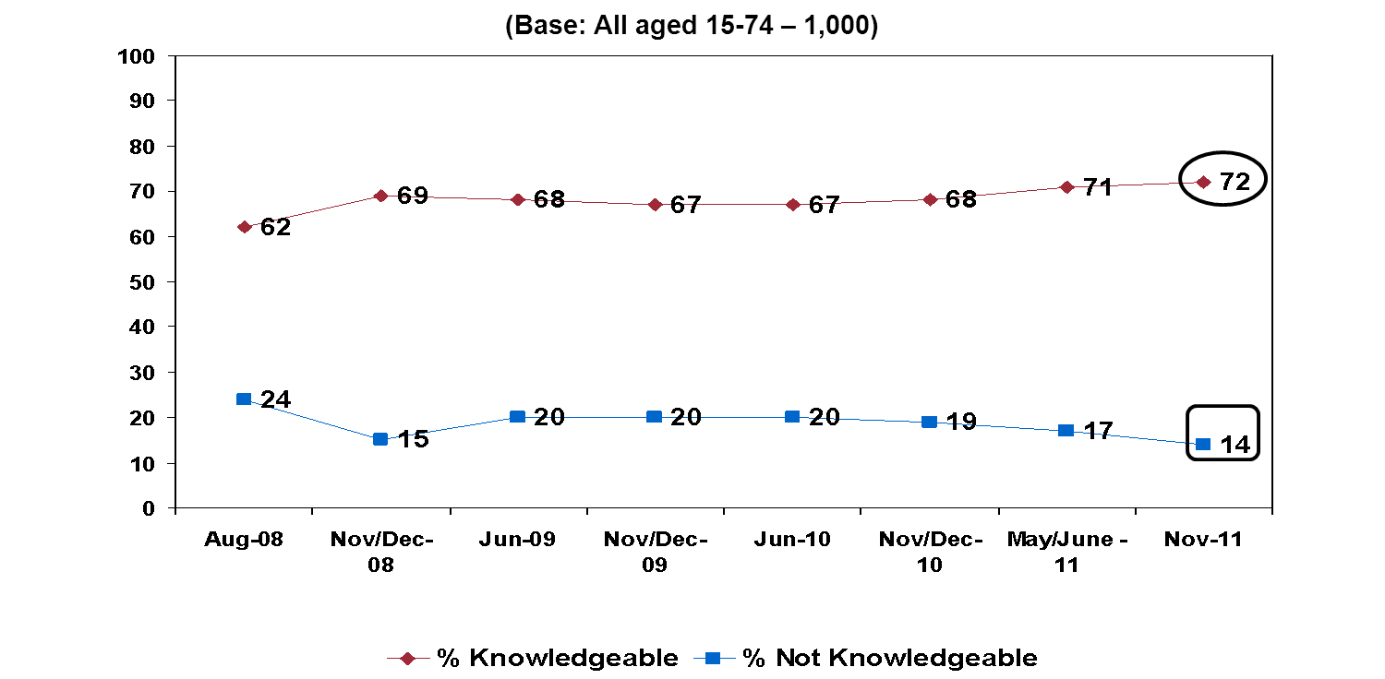
The third consumer metric in relation to consumer empowerment examines how protected consumers feel in relation to their consumer rights, the results of which are shown in Figure 3. There has been an increase of 5% since the previous wave to just over 3 in 4 (76%) consumers who feel protected in relation to their consumer rights, another recorded high; whilst the number who assert they do not feel protected has remained under 1 in 10, at 8% consistent with the previous survey.

- Protected Regarding Consumer Rights
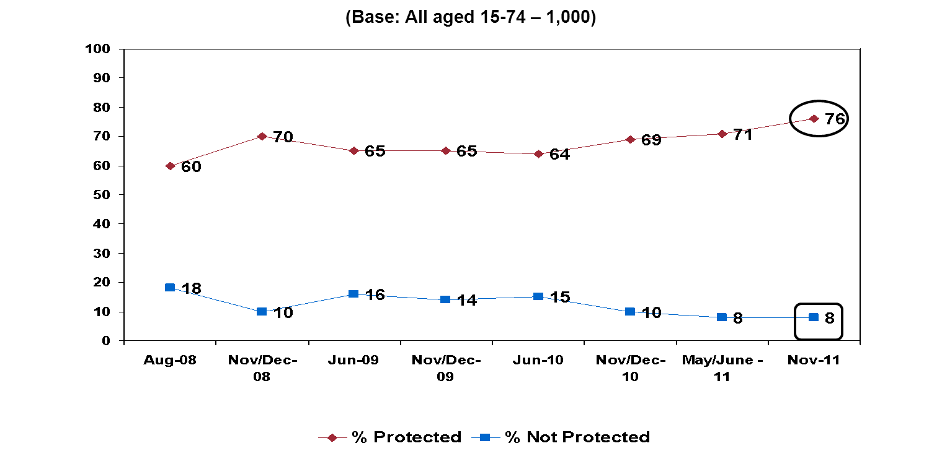
Figure 4 presents the results of the three key empowerment indicators; confidence, knowledge and protection, by demographic profile. A red circle denotes a significant difference higher than the total sample while a blue square highlights groups for whom results are significantly lower than the total sample.

In terms of demographics or income groups which are significantly higher than the total sample, the social economic grouping ABC1/F50+ assert higher confidence, knowledge and protection levels than the total sample surveyed. In contrast, those with lower than the average stated levels of empowerment are most likely to be found in the younger age group of 15-24s and the socio economic group of C2DE/F50-.

- Summary of Empowerment
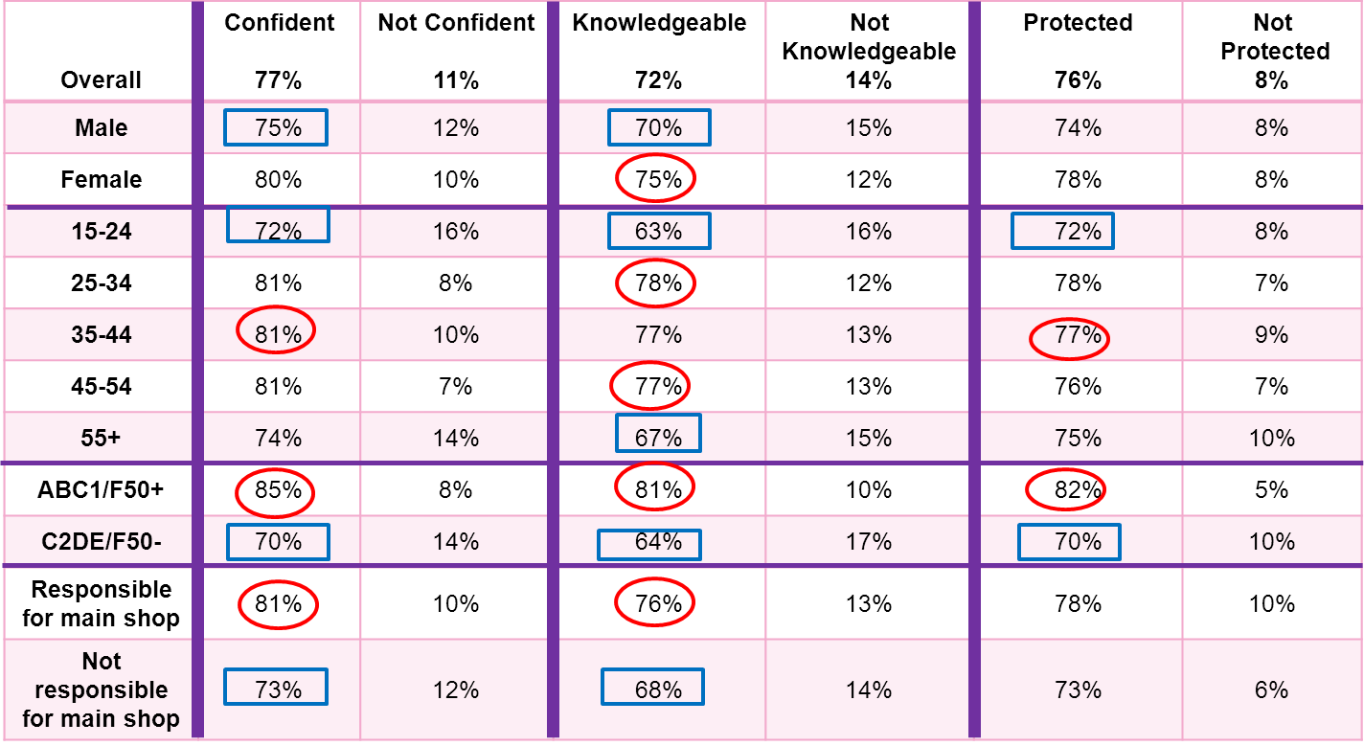

Customer Service
In this section, consumers’ experience with customer service is examined. Figures 5 and 6 depict, by sector, consumer contact with customer service and also the means through which contact occurred.

Approximately 1 in 5 had reason to contact customer service in the last 12 months for shops selling clothing or footwear (19%) and supermarkets (20%). The interaction tended to be face to face, 90%, and 87% respectively.

Phone is the most likely method for those who had to contact customer service with respect to TV service providers (79%), waste services (70%), energy suppliers (56%), insurance products and services (52%) and communication services (49%). 17% of consumers had cause to contact customer service in relation to airlines and the method most used was the internet at 43% followed by email at 18%.

- Experience with Customer Service – I
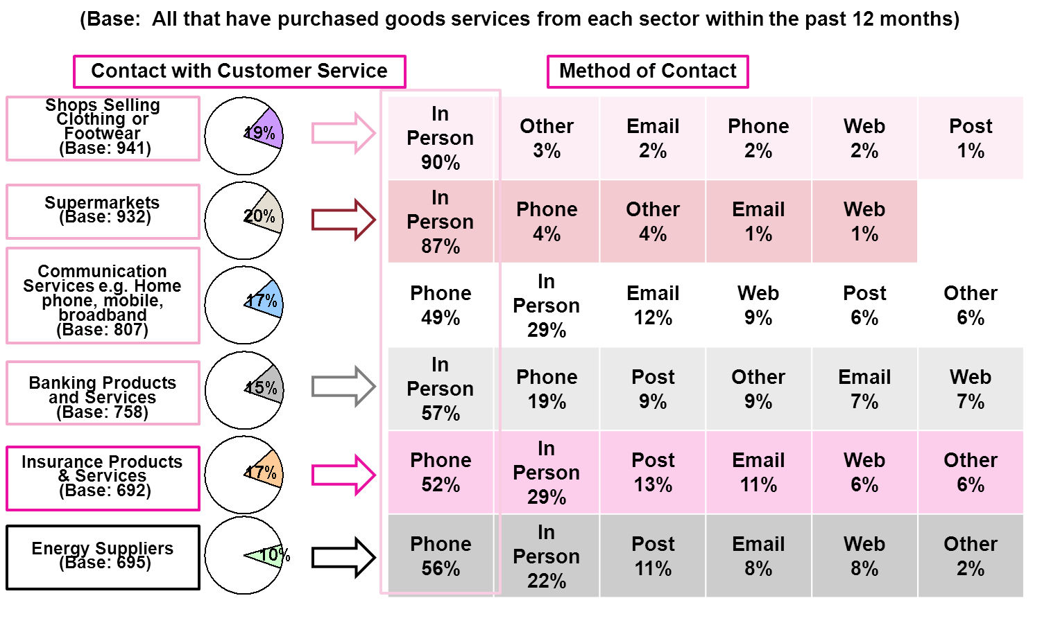

- Experience with Customer Service - II
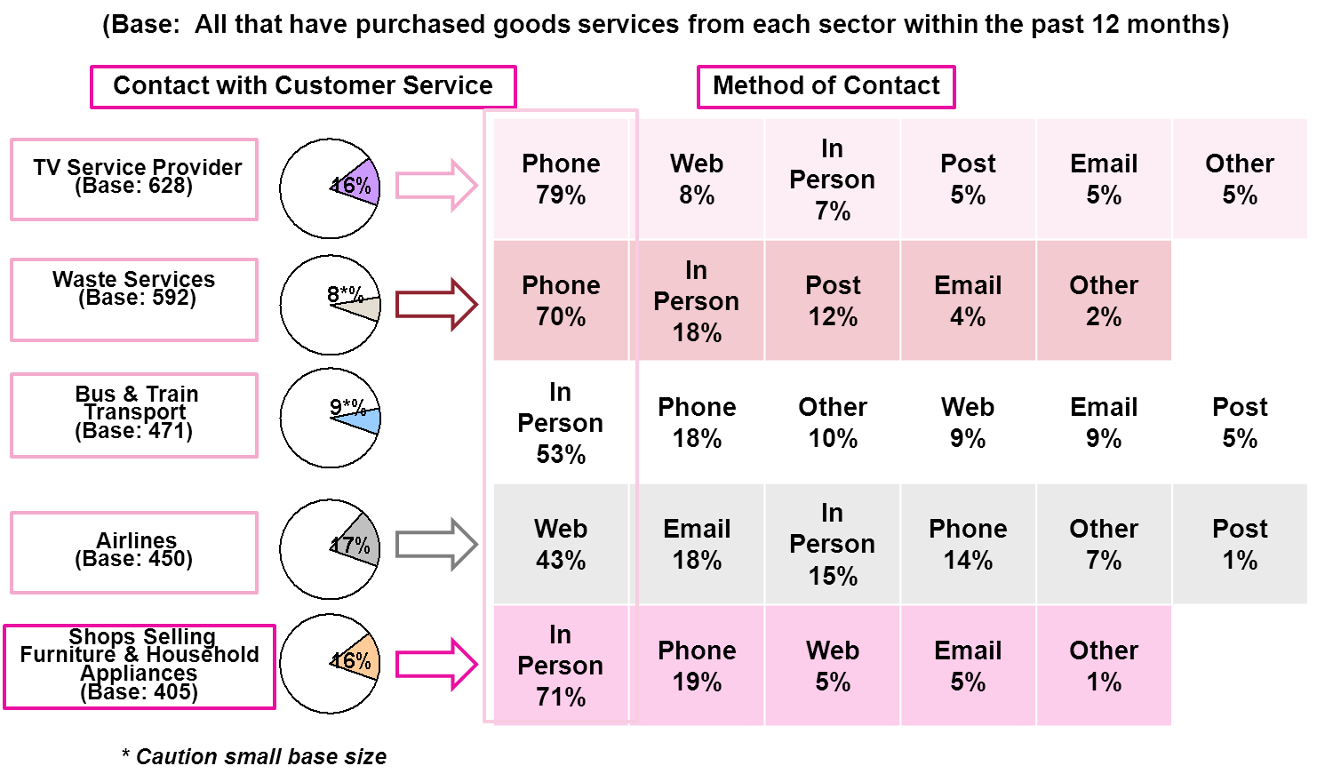

Figures 7 and 8 illustrate customer service satisfaction levels by sector. Supermarkets and shops selling clothing or footwear record the highest level of satisfaction at 91%. A contributory factor to this may be that the interaction tended to be face to face.
- Satisfaction with Customer Service – I
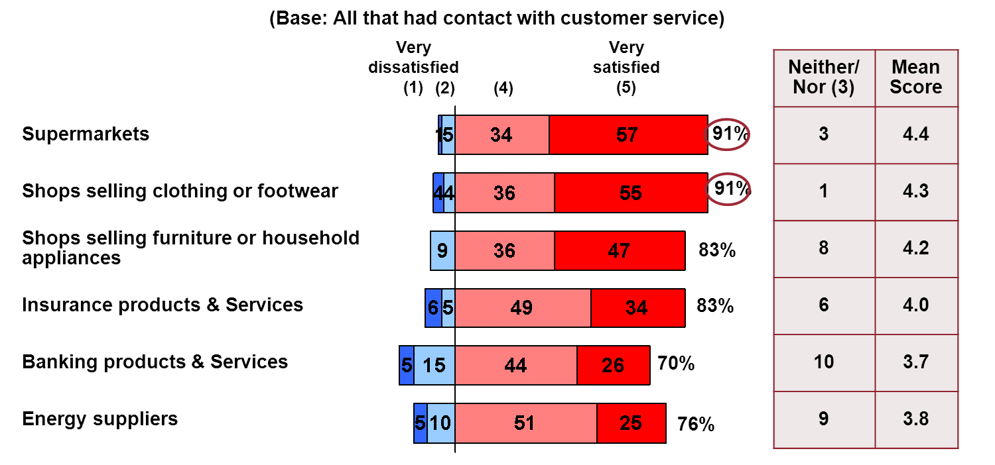
Airlines had the lowest rating for satisfaction with customer service at 64%, where the interaction was predominantly via the web. Airlines also recorded the highest dissatisfaction rating with 3 in 10 (30%) consumers stating that they were dissatisfied with the level of customer service.

- Satisfaction with Customer Service - II
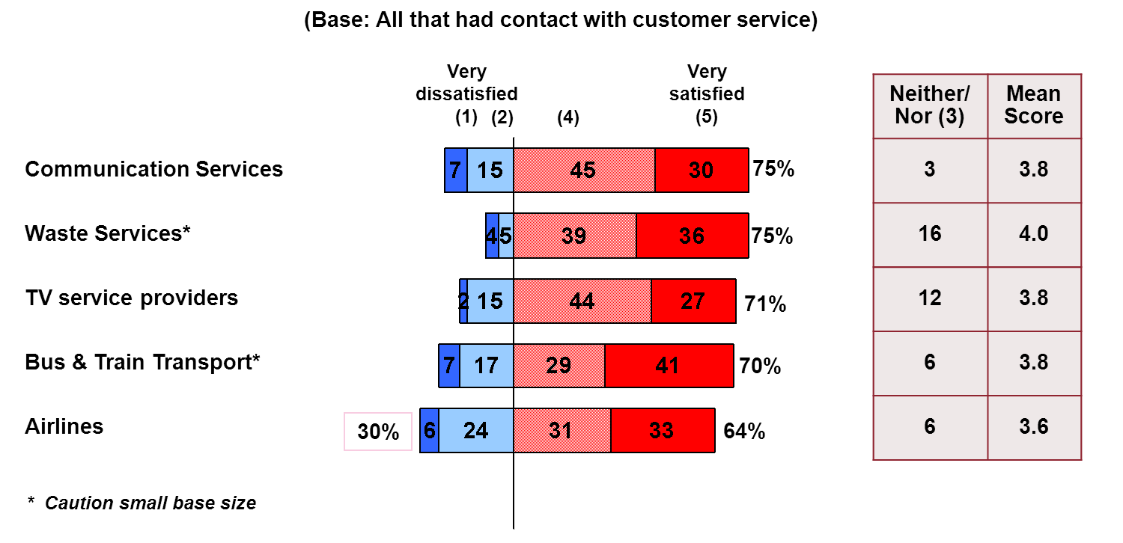
Figure 9 presents consumers’ likely action following good or bad customer service experiences. It can be seen that effective customer service can be rewarded with 2 in 5 (58%) consumers stating that as a result of receiving good customer service that they would continue to do business with the provider. A similar portion (56%) would tell people they know of their good experience.

The reverse is also true with almost 2 in 3 (57%) consumers stating that they would stop doing business with a provider if they received bad customer service and 24% stated that they would do less business with the provider as a result of bad customer service. 46% stated that they would tell people they know of their bad customer service experience.

- Likely Action as a result of Good or Bad Customer Service
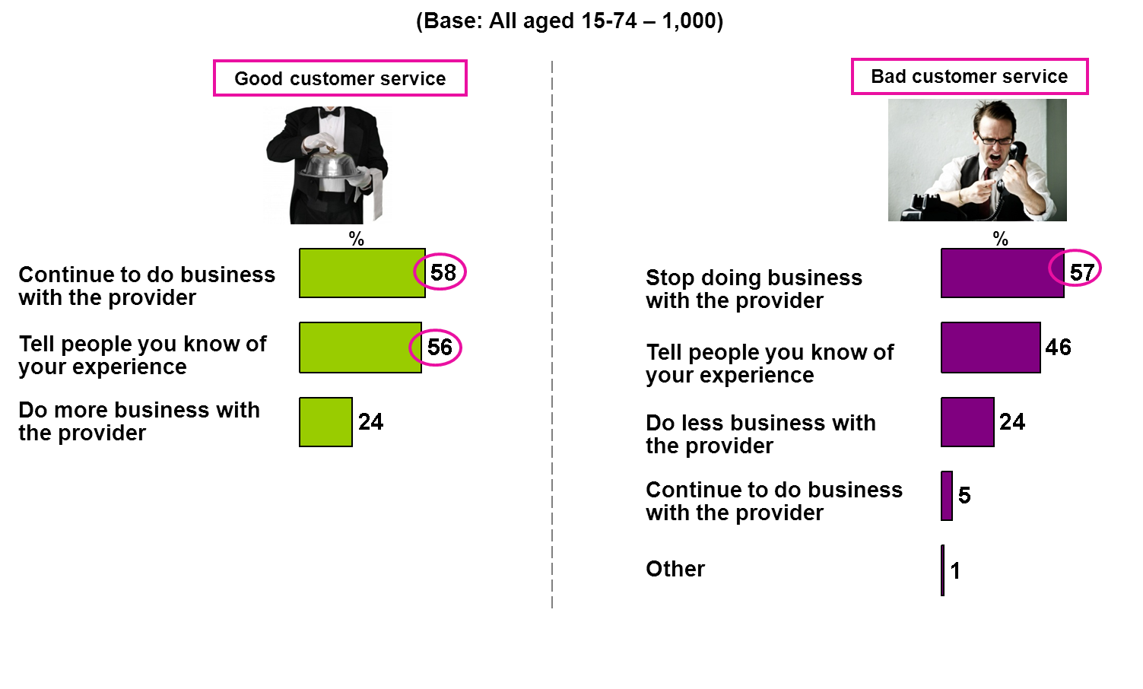

Key Points
In November 2011 the National Consumer Agency continued its programme of consumer research, the purpose being to monitor, analyse and record patterns of consumer behaviour and experiences in Ireland. The research, consistent with previous surveys, was conducted by means of face-to-face interviewing with a nationally representative sample of 1,000 people between the ages of 15 to 74. This report presented the results relating to Irish consumers’ experiences and attitudes with regard to consumer empowerment and consumers’ experience with customer service.

The key findings are:

Consumer Empowerment Levels
- 77% of consumers feel confident in respect of their consumer rights with 11% not feeling confident.
- 72% claim they are knowledgeable of their rights, up 1% point to the highest level to date. 14%, down 3%, stated that they are not knowledgeable of their rights.
- 76% feel protected in respect of their rights, up 5% points to another record high; with the number that do not remaining at 8%, the lowest level recorded to date.
Customer Service
- Supermarkets and shops selling clothing or footwear had the highest level of satisfaction with customer service, both at 91%. The interaction tended to be face to face, 87% and 90% respectively. The lowest level of satisfaction, at 64%, applied to those contacting airlines’ customer service. Airlines also had the highest proportion of consumers claiming dissatisfaction at 30%.
- Nearly 3 in 5 (58%) consumers stated that as a result of good customer service that they would continue to do business with the provider. A similar portion (57%) said that they would stop doing business with a provider as a result of receiving bad customer service.

The percentage changes mentioned in this report refer to an increase or decrease in percentage points.

