National Consumer Agency
Market Research Findings:
Household Budgeting and Impact of the Recession
October 2010

Table of Contents
1 Introduction and Methodology 3
2 Summary Findings 5
3 Household Budgeting and Impact of the Recession 7

Table of Figures
Figure 1 Household Income and Expenditure 7
Figure 2 One Word to Describe: Ireland Right Now 8
Figure 3 One Word to Describe: How You Yourself Feel Right Now 9
Figure 4 Economic Outlook - I 9
Figure 5 Economic Outlook - II 11
Figure 6 Spending Thrift 12
Figure 7 Coping Behaviour 13
Figure 8 Lifestyle 13
Figure 9 Change in Behaviour as a Result of Recession - I 14
Figure 10 Change in Behaviour as a Result of Recession - II 15
Figure 11 One Word to Describe: Ireland in 12 Months Time 16
Figure 12 One Word to Describe: Your Future 16

Introduction and Methodology
In June 2010 Amárach Research continued the programme of consumer research conducted by the National Consumer Agency with a view to monitoring, analysing and recording patterns of consumer behaviour and experiences in Ireland.

A key feature of the market research is the comparison of data collected in previous waves of market research, i.e. the benchmark survey (conducted in November/December 2007), Wave 1 Survey (August 2008), Wave 2 (November/December 2008), Wave 3 (May/June 2009), Wave 4 (November/December 2009), with the current consumer landscape. This comparison provides a valuable time-series.

The research, consistent with previous surveys, was conducted by means of face-to-face interviewing with 1,000 people between the ages of 15 to 74. To ensure that the data is nationally representative, quotas were applied on the basis of age, gender, social class and region. Interviews were conducted over a four-week period in June 2010.

The Agency’s programme of market research explores a wide range of consumer behaviour and experiences in Ireland, including:

- The level of consumer empowerment, awareness of consumer rights and the propensity to complain,
- Consumer behaviour with regard to shopping and pricing,
- Consumers’ response to the recession,
- Trends in switching goods / service providers.

The results of the market research are compiled across four volumes. This report details the results relating to Irish consumers’ experiences and attitudes with regard to household budgeting and the impact of the recession.

PowerPoint versions of the slides in this report, in addition to details of all of the Agency’s research activities, are available at
http://www.nca.ie/eng/Research_Zone/Reports/.

Summary Findings
The NCA’s latest market research, relating to household budgeting and impact of the recession, reveals an increase in the number of consumers that experienced a reduction in their income in the preceding 12 months compared with the previous wave of market research, which was conducted in November/December 2009 (62% versus 53%). When questioned about expenditure, 64% of consumers reported that their spending has either remained the same or increased.

With regard to the economic outlook of consumers, almost 2 in 5 (38%) disagreed with the statement that “Ireland will be through the worst of the recession in 12 months time”. The same proportion (38%) indicated that they now focus less on acquiring possessions and more on having memorable experiences such as holidays.

Almost 3 in 4 (73%) respondents stated they will continue to shop around for better deals when the economic situation improves. 2 in 3 (66%) consumers say that they have learnt to manage their finances better as a result of the recession and will continue to do so going forward.

When examining spending thrift, 72% of consumers believe that the recession has focussed them into thinking carefully about what and when to buy with just under 7 in 10 (67%) believing the recession is a good opportunity to pick up bargains in the sales. In all, 3 in 5 consumers (61%) are actively seeking out cheaper ways of living, while 59% would prefer to switch between brands of things they buy than do without them at all.

Despite the impact that the recession has had, 70% of respondents remain positive stating that they are enjoying life as much as ever.

When asked how their behaviour has changed as a result of the recession, 44% of consumers are budgeting for household expenses more and buying an increased proportion of goods on special offer. 34% are spending more time “bargain hunting” when buying groceries with 31% spreading their shopping across a number of shops and 30% of consumers spending less on groceries overall.

Household Budgeting and Impact of the Recession

Figure 1 presents data relating to household income and expenditure. The figures in brackets, in Figure 1 and throughout the report where data is comparable, refer to the pervious wave of market research conducted in November and December 2009.

- Household Income and Expenditure
From Figure 1, it can be seen that there has been an increase in the number of consumers who have experienced a reduction in their household income in the previous 12 months, compared with the previous wave of research (62% versus 53%). A similar proportion, 64%, cited that their expenditure has either remained the same or increased.

Figures 2 and 3 are visual representations, known as Wordles, of responses to the questions: what one word would you use to describe “Ireland right now?” and “how you yourself feel right now?” Wordles give greater prominence to words stated more frequently in response or, more simply, the larger the word appears in the Wordle, the more frequently it was mentioned in responses.

It can be seen from Figure 2 that Bad was the word most frequently stated, followed by other negative sentiments such as Poor, Bleak, Disaster, Depressing, Recession and Depressed.

- One Word to Describe: Ireland Right Now
(Base: All aged 15-74 – 1,000)

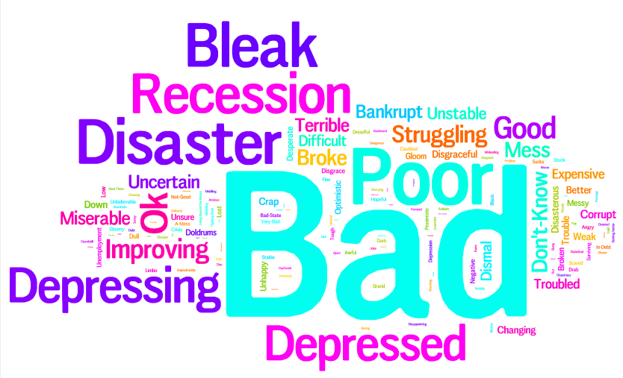

When asked, however to describe “how you yourself feel right now?” the sentiments expressed were more positive with Good and Happy being the most prominent responses, as illustrated in Figure 3 below.

- One Word to Describe: How You Yourself Feel Right Now
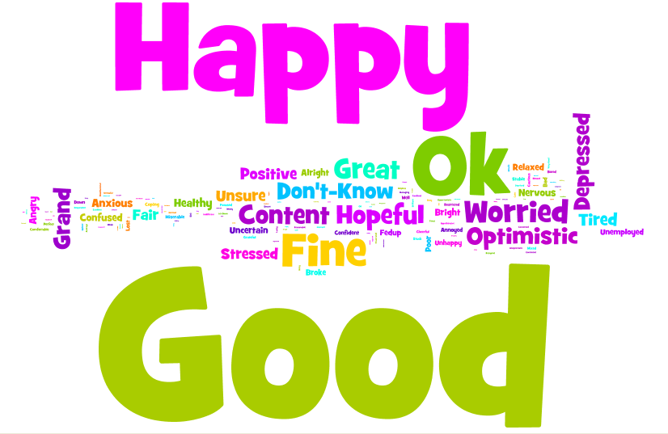
(Base: All aged 15-74 – 1,000)

Figure 4 and Figure 5 present data relating to the economic outlook of consumers.

- Economic Outlook - I
Figure 4 indicates that 38% of consumers disagree with the proposition that Ireland will be through the worst of the recession in 12 months time. Looking at the detailed data for this statement, not shown, those aged 35 and over and those in the C2DE socio economic grouping are least optimistic about the economic future with over 2 in 5 in these categories disagreeing with the statement.

Overall, 38% indicated that they would focus less on acquiring possessions and more on having memorable experiences such as holidays, with women (41%) and those in the ABC1 socio economic grouping (43%) most likely to agree with the statement.

Also in Figure 4 it can be seen that almost 3 in 4 (73%) consumers claimed they would continue to shop around for better deals even when the economy has stabilised and returned to growth. This increases to over 4 in 5 (83%) for the 25-34 year old age group. By contrast, 15-24 year olds (64%) and those aged 55+ (62%) are least likely to say that they will continue to shop around for better deals when the economic situation improves.

Figure 5 shows that just over 1 in 2 (51%) of all respondents are not any more relaxed about spending than they were 6 months ago. A quarter (25%) of those in the ABC1 socio economic grouping are more relaxed about spending now than they were six months ago compared to 20% of consumers in the C2DE socio economic grouping.

- Economic Outlook - II

2 in 3 (66%) consumers say that they have learnt to manage their finances better as a result of the recession and will continue to do so going forward.

In regard to consumer spending thrift as illustrated in Figure 6 and similar to the pervious wave of NCA research, almost 3 in 4 (72%) believe that the recession has focussed them on thinking carefully about what and when they buy.

Just under 7 in 10 (67%) believe that the recession is a good opportunity to pick up bargains in the sales, and a similar proportion are consciously trying to buy fewer things nowadays and are putting off buying large spend items until the current situation improves.

- Spending Thrift

Figure 7, below, presents data relating to the coping behaviour of consumers and, similar to the previous wave of research conducted in November /December 2009; circa 3 in 5 (61%) are actively seeking out cheaper ways of living while 59% would prefer to switch between brands of things they buy than do without them at all.

- Coping Behaviour
In Figure 8, data is shown relating to how consumers lifestyles have changed with the recession.

- Lifestyle
It can be seen that consumers are continuing to remain positive with 7 in 10 (70%) claiming to be enjoying life as much as ever. The number of consumers that are reluctant to plan any holidays until things improve in the economy has fallen back slightly since the previous research conducted in late 2009, with just over 1 in 4 (26%) now disagreeing with this statement.

Figures 9 and 10 display the responses when consumers were asked about changes in behaviour as a result of the recession.

From figure 9 it can be seen that, as a result of the economic downturn, over 2 in 5 (44%) consumers are budgeting for household expenses more, and buying goods on special offer more. Consumers are less likely to be eating takeaway foods and are more likely to be preparing home made meals from scratch.

- Change in Behaviour as a Result of Recession - I

As illustrated in Figure 10 below, 1 in 3 (34%) consumers is spending more time ‘bargain hunting’ when buying groceries than pre-recession.

Approximately 3 in 10 (31%) are spreading their shopping more across a number of shops, while a similar proportion (30%) are spending less on their groceries overall.

- Change in Behaviour as a Result of Recession - II
Figures 11 and 12 show the responses of consumers when asked to describe, using just one word, “Ireland in 12 Months Time” and “Your Future” respectively.

When asked about “Ireland in 12 months time” (Figure 11) the most common response was “Better” but after this, the sentiments were mixed with words such as Worse, Don’t Know and Good the most commonly mentioned.

- One Word to Describe: Ireland in 12 Months Time
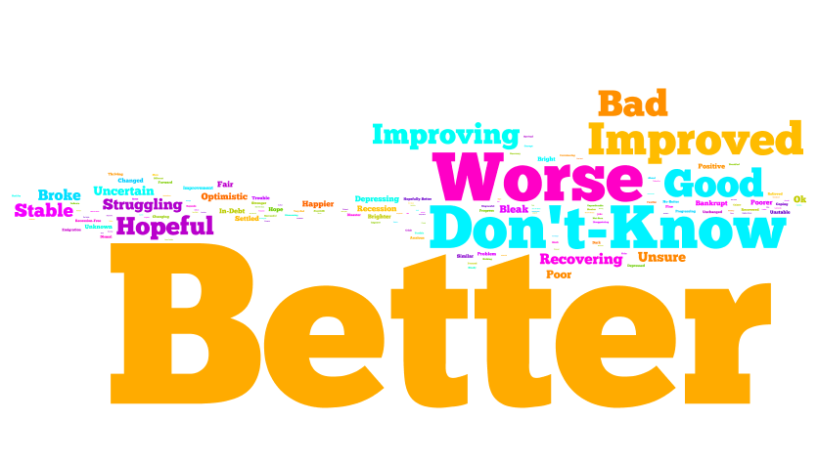
(Base: All aged 15-74 – 1,000)

When asked about “Your Future” the most common consumer responses used positive words such as Good, Hopeful, Bright followed again by mixed sentiment such as Uncertain and Bleak. Encouragingly, a fair number of those questioned declared themselves Optimistic.

Figure 12 One Word to Describe: Your Future
(Base: All aged 15-74 – 1,000)

