
National Consumer Agency

Market Research Findings:
Shopping and Pricing

November 2011
Table of Contents
1 Introduction and Methodology 4
2 General Shopping and Pricing 6
3 Grocery Shopping 13
4 Key Points 21

Table of Figures
Figure 1 Shopping Around 6
Figure 2 Most influencing factor in determining where to shop when comparing prices – I 7
Figure 3 Most influencing factor in determining where to shop when comparing prices – II 8
Figure 4 Most influencing factor in determining where to shop when comparing prices – III 9
Figure 5 Most influencing factor in determining where to shop when comparing prices – IV 9
Figure 6 Most influencing factor in determining where to shop when comparing prices – V 10
Figure 7 Key Influencing Factors in Determining where to shop 11
Figure 8 Incidence of checking prices 12
Figure 9 Overall Awareness of the Price of Everyday Goods 13
Figure 10 Attitudes to Supermarkets 14
Figure 11 Main Reasons for Choice of Main Grocery Shop 15
Figure 12 Change in Shopping behaviour within the last 12 months 16
Figure 13 Own Brand Versus Regular Brand 17
Figure 14 Own Brand versus Regular Brand Preference – I 18
Figure 15 Own Brand versus Regular Brand Preference – II 18
Figure 16 Influencing factors when purchasing own brand products 19
Figure 17 Reasons for not purchasing own brand products 20
Figure 18 Special Offer Seekers 20

Table of Tables
Table 1 Previous Waves of Market Research 4

Introduction and Methodology
In May and June 2011 Amárach Research continued the programme of consumer research conducted on behalf of the National Consumer Agency with a view to monitoring, analysing and recording patterns of consumer behaviour and experiences in Ireland.

A key feature of how this market research is used involves the comparison of data collected in previous iterations (see Table 1 below), with that reporting on the current consumer landscape. This comparison provides a valuable time-series.
- Previous Waves of Market Research

Survey | Conducted
Benchmark | November/December 2007
Wave 1 | August 2008
Wave 2 | November/December 2008
Wave 3 | May/June 2009
Wave 4 | November/December 2009
Wave 5 | June 2010
Wave 6 | November/December 2010

The latest research, consistent with previous surveys, was conducted by means of face-to-face interviewing with 1,000 people between the ages of 15 to 74. To ensure that the data is nationally representative, quotas were applied on the basis of age, gender, social class and region. Interviews were conducted over a four-week period in May and June 2011.

The Agency’s programme of market research explores a wide range of consumer behaviour and experiences in Ireland, including:
- The level of consumer empowerment, awareness of consumer rights and the propensity to complain
- Consumer behaviour in relation to shopping and pricing
- Consumers’ response to the recession and household budgeting
- Trends in switching goods/service providers and
- Consumer experience with regard to direct selling

The findings of the market research are compiled across a number of volumes. This report, the fifth release in the current series, details the results relating to Irish consumers’ experiences and attitudes with regard to overall Shopping and Pricing (Section 2) as well as questions which specifically relate to Grocery Shopping (Section 3).

PowerPoint versions of the slides in this report, in addition to details of all of the Agency’s research activities, are available at http://www.nca.ie/eng/Research_Zone/Reports/.

General Shopping and Pricing
The propensity of consumers to shop around when purchasing goods or services is depicted in Figure 1, which presents the latest data and comparable results from four preceding iterations of market research. Figures in brackets refer to the previous most recent wave of research conducted in Nov/Dec 2010. The number of consumers who shop around has increased significantly from 71% in the previous wave of research to 82% in the latest; a third (33%) of consumers always compare or shop around for better prices while a further 1 in 2 (49%) compare or shop around sometimes. The number of consumers that never compare prices or shop around has halved from the 10% recorded in November/December 2010 to its current level of 5%.

- Shopping Around
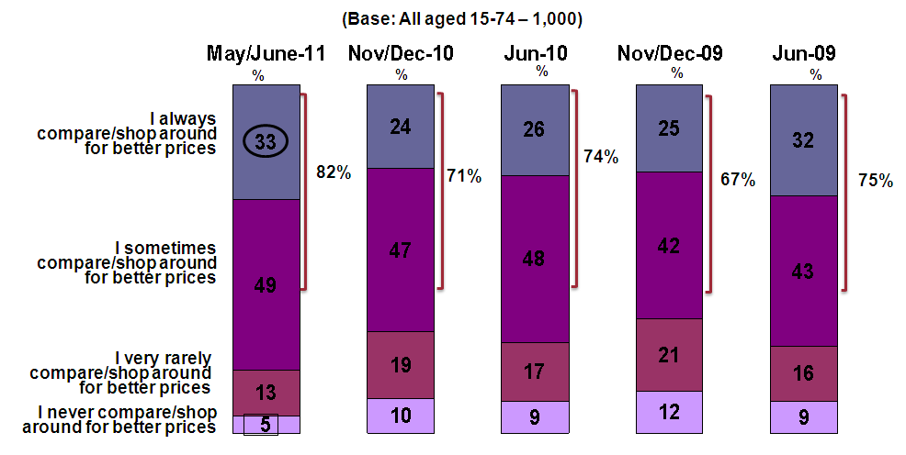

When comparing prices within individual sectors the most influential factor in determining where to shop for products/services is shown in Figures 2 to 6.

From Figure 2 it can be seen that two thirds (66%) of consumers do not compare prices when purchasing from pharmacies, nearly 1 in 2 do not compare prices for restaurants, take-aways and hotels (48%) and convenience stores/newsagents (45%). For those that do compare prices, recommendations are considered the most influencing factor in relation to restaurants, take-aways and hotels and clothing/footwear.

- Most influencing factor in determining where to shop when comparing prices – I
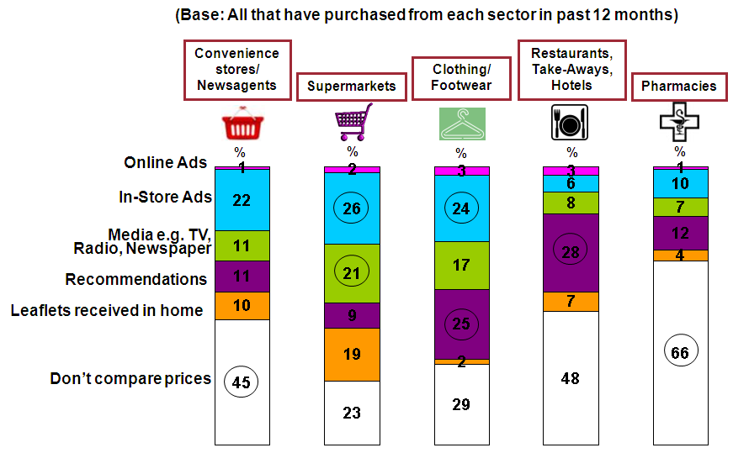

As can be seen from Figure 3, the majority of consumers do not compare prices for doctors, hospitals and other medicals (74%) and pubs (68%). For personal care such as hairdressers etc., 31%, rely on recommendations when choosing where to shop. Media is considered most influential in determining where to shop for communication services.

- Most influencing factor in determining where to shop when comparing prices – II
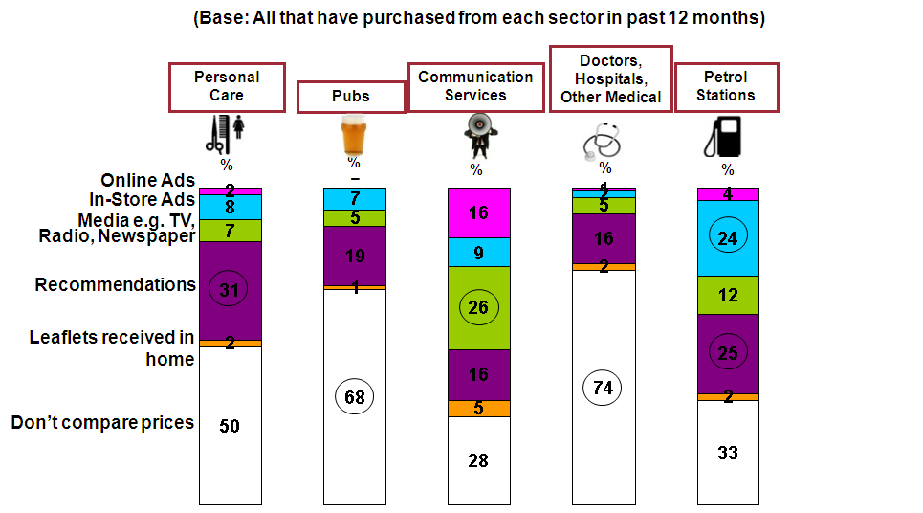

When choosing energy supplier or TV service provider, consumers are most likely to be influenced by media advertising, 29% and 28% respectively as shown in figure 4. Recommendations, online and media advertising feature strongly when choosing insurance (28%).

- Most influencing factor in determining where to shop when comparing prices – III
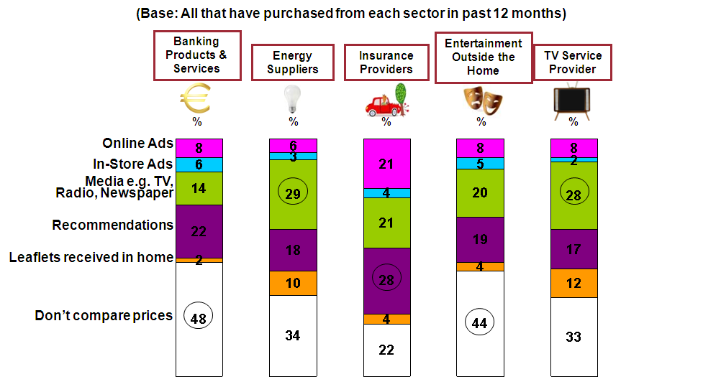
As shown in Figure 5, nearly half (47%) of consumers buying air tickets use online adverts as a mode of comparison to seek out the best value. For furniture purchases, shoppers are most influenced by media advertising (31%).

- Most influencing factor in determining where to shop when comparing prices – IV
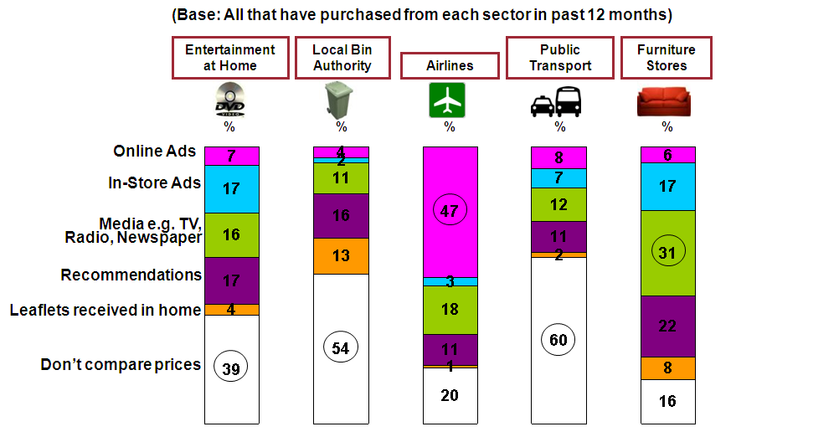

Recommendations are considered most influential when comparing prices in relation to building and related services (54%) and car dealers (31%) as depicted in Figure 6. Online advertising is considered most influential when comparing prices of travel agents.

- Most influencing factor in determining where to shop when comparing prices – V
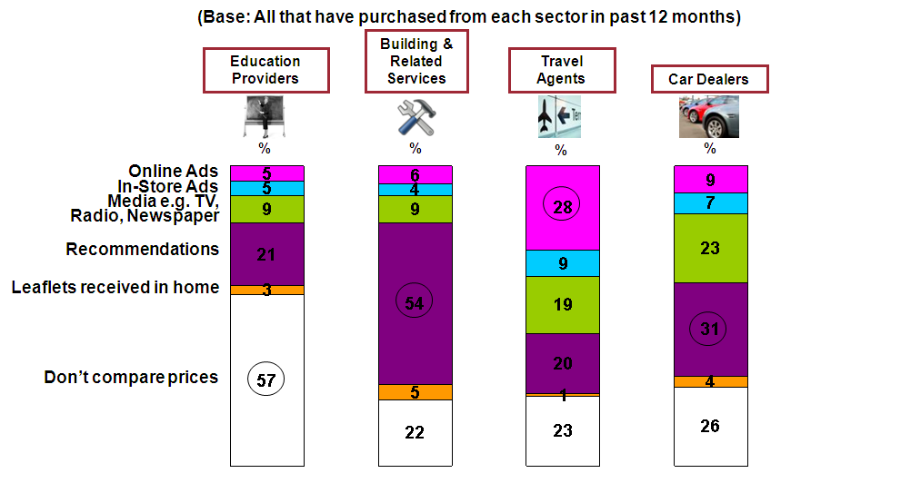

From Figure 7 it can be seen that price remains the principle determining factor when deciding where to shop.

Price has been the leading determinant since the beginning of the research series, however the numbers stating price as their main reason for choosing where to shop has fallen back dramatically over the last two series of research from a record high of 72% recorded in June 2010 to 53% at present.

- Key Influencing Factors in Determining where to shop
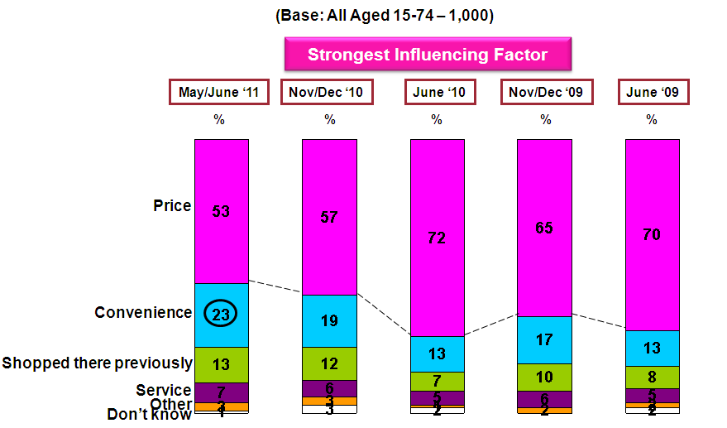

Convenience has reached its highest level to date, in this series, with nearly 1 in 4 (23%) shopping on this basis, the number citing “shopped there previously” and “service” as determining factors remains consistent with the results from the November/December 2010 survey.

As can be seen from Figure 8, over 4 in 5 (82%) consumers continue to check the price of products and 71% monitor receipts, both figures remain consistent with the previous iteration of research.

2 in 3 (66%) consumers check receipts to verify special offers have been recorded accurately. Consumers are less diligent when checking unit pricing with just under half (47% down 4%) claiming to do so, 28% never check unit pricing.

- Incidence of checking prices
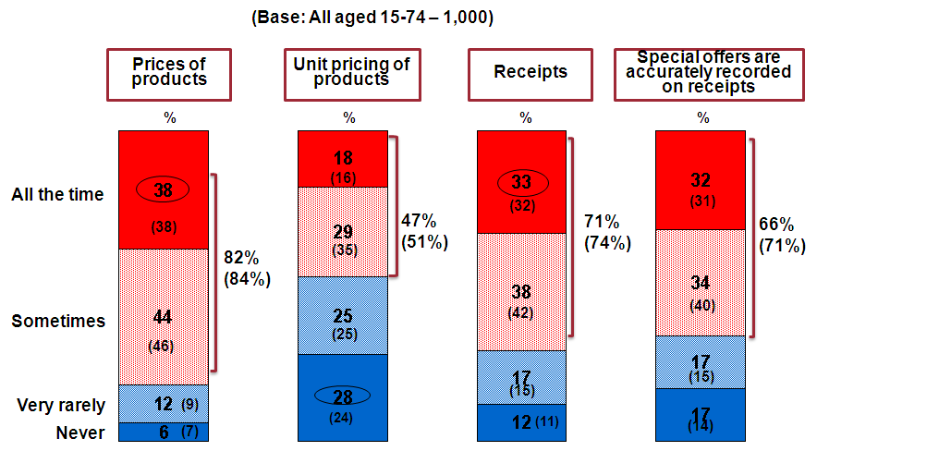

Grocery Shopping
As grocery shopping accounts for a regular and in many cases a large portion of household spending the following section examines in greater detail consumer behaviour and experience in this sector.

As shown in Figure 9, over 7 in 10 (71%) consumers state they are aware of the price of everyday grocery goods, an increase of 15% from the figure recorded in November/December 2010. When asking those responsible for the main grocery shop, the number asserting awareness of the price of everyday goods increases to 85%.

- Overall Awareness of the Price of Everyday Goods
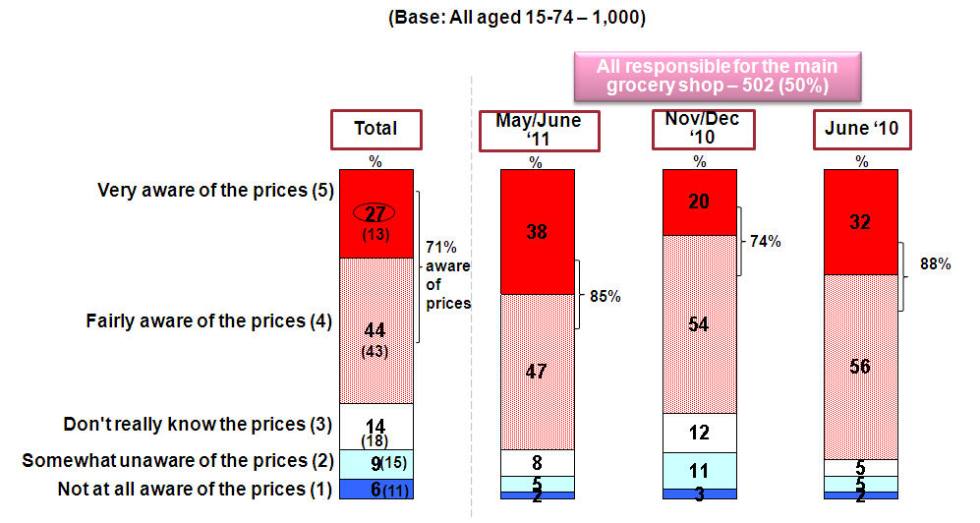

The results of a new question in this iteration of research, examining attitudes to supermarkets, are depicted in Figure 10. 81% of those responsible for the main grocery shop agreed with the statement ‘’that you need to shop around in order to achieve the best value’’. 65% also agreed that ‘’the supermarket offering the best value for money changes week on week’’.

Less than half of main grocery shoppers agreed that ‘’there is one supermarket that is cheaper than all the rest ‘’with 30% disagreeing with the same statement.

- Attitudes to Supermarkets
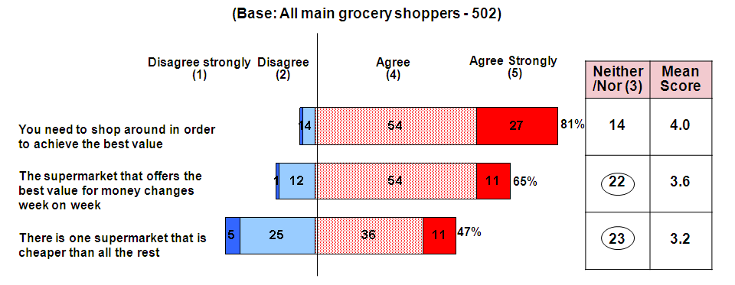

The main reasons for choosing where to shop for groceries are presented in Figure 11. Price remains the leading factor as it has since the beginning of the research but the number choosing where to shop based on price (63% down 9%) has dipped back to figures seen in November/December 2009.

Convenience is the second most important factor at 54% increasing 5% since the last wave of research with the quality of product increasing in importance (16%) up 4% from the November/December 2010 figure.

- Main Reasons for Choice of Main Grocery Shop
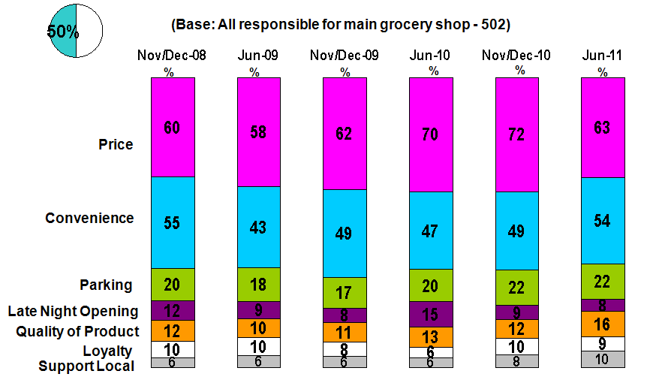

Figure 12 depicts the change in shopping behaviour of main grocery shoppers in the past 12 months. As can be seen 1 in 3 shoppers (33%) now split their main grocery shop across different retailers.

Roughly 1 in 8 main grocery shoppers no longer do a “main” shop but do a number of smaller shops (13%). The same proportion, 13%, have opted to purchase more own brand products; 12% choose a store dependent on the offers advertised with a further 10% switching the store in which they do their main grocery shop.

Over a third of those responsible for the main grocery shop (36%) continue to shop as they have previously done. A small proportion, (2%) have switched to doing their grocery shopping online. From data not shown, 1 in 5 (20%) of those responsible for the main grocery shop buy groceries online with 13% doing so at least once a week.

- Change in Shopping behaviour within the last 12 months
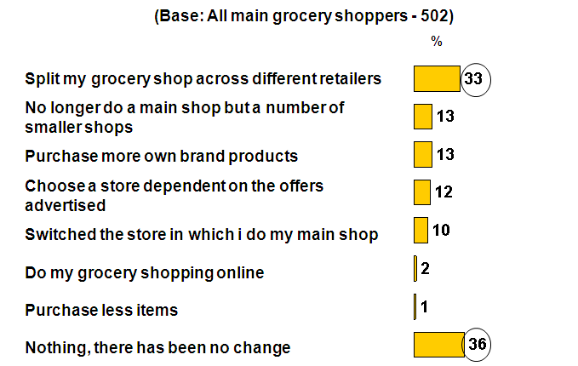

Figure 13 examines the breakdown of an average weekly shop in terms of branded and own brand products, with own brand products now accounting for 35% of the grocery basket, consistent with figures found in the previous wave of research in November/December 2010.

Branded products therefore account for 65% of the grocery basket and from detailed data not shown, it was found that branded products account for a higher proportion of the grocery basket for overs 55s (71%), the socio economic grouping ABC/F50+ (70%) and those who are not aware of the prices of everyday goods (74%).

- Own Brand Versus Regular Brand
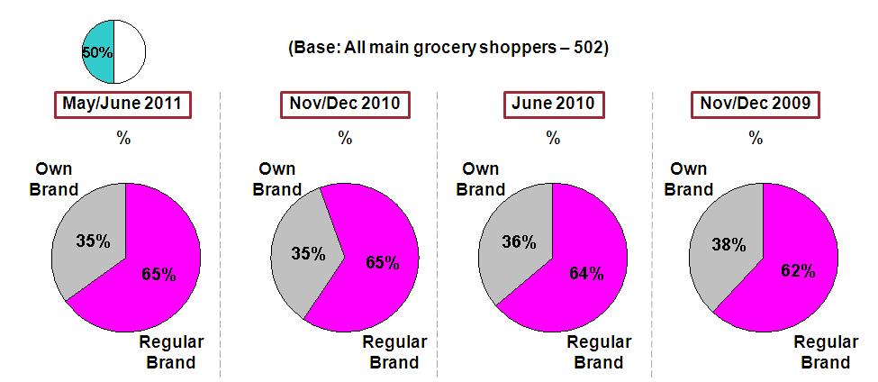

Figures 14 and 15 show the breakdown, by category, of traditional branded and own brand purchases. Nearly 9 in 10 (87%) buy regular brand beer, followed by tea or coffee (84%) and baby products (80%).

There has been an increase of 5% in those opting for own brand breakfast cereal since the previous survey, with 1 in 4 now purchasing own brand cereals. Similarly a 10% increase was observed in those choosing own brand yoghurts (at 37%) and an 8% increase in own brand soft drinks (at 38%).

As shown in Figure 15, when choosing own brand items consumers are more likely to purchase own brand toilet tissue or kitchen towel (74%) followed by household products (66%) with just over half (53%) buying own brand milk. Almost in 1 in 2 consumers (46%) purchase own brand juice drinks. There has been an increase of 7%, now at 75%, in shoppers buying branded deli/processed meats.

- Own Brand versus Regular Brand Preference – I
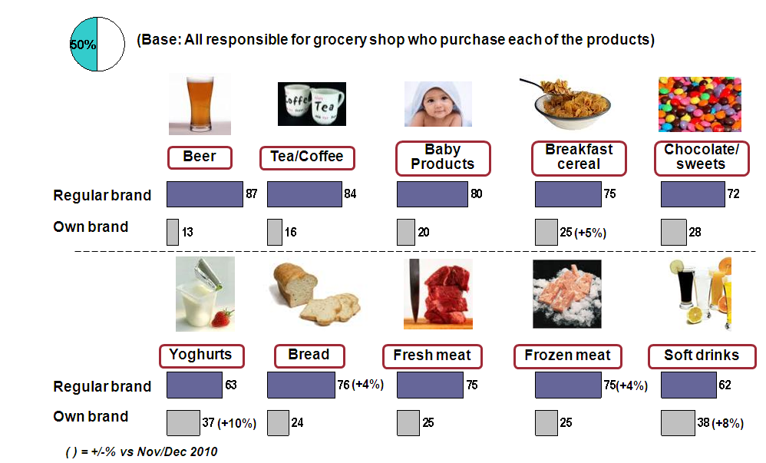

- Own Brand versus Regular Brand Preference – II
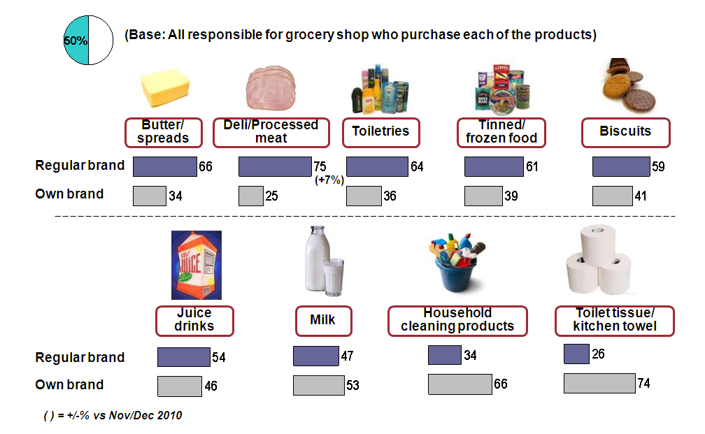

When purchasing own brand products, 37% of main grocery shoppers are primarily concerned with the quality of the product, as illustrated in Figure 16. The second biggest influencing factor is price as cited by 34% of main grocery shoppers, and for a fifth (19%) of shoppers past experience of the product is an important influencing factor.

- Influencing factors when purchasing own brand products
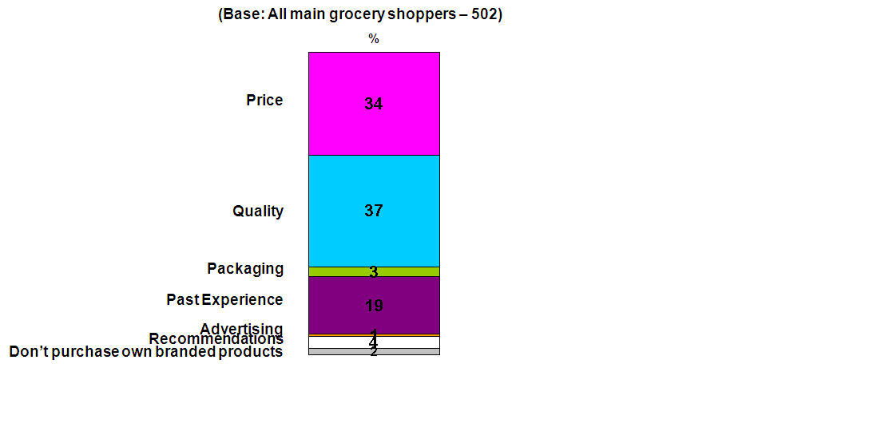

The reasons recorded for not purchasing own brand products are depicted in Figure 17. ‘’Happy with the quality of existing products’’ (44%), ‘’happy with the price of existing product’’ (31%) and ‘’unsure of the quality of an own brand equivalent’ (30%) are the main reasons given by consumers for not switching to own brand products. 11% are not aware of an own brand option for certain products and 5% have been advised against buying the own brand version.
- Reasons for not purchasing own brand products
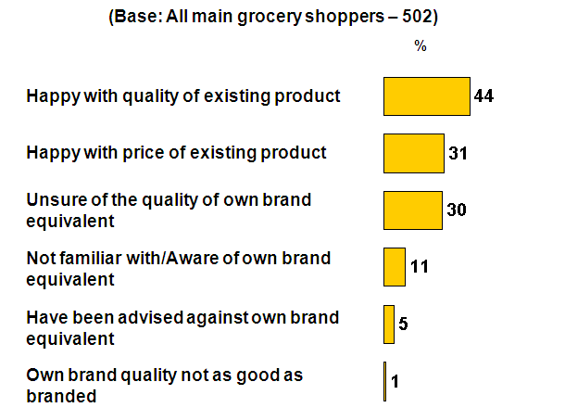

Figure 18 shows, in relation to special offers, that those responsible for the main grocery shop are more likely to visit their usual store and pick up special offers (66%) while 28% select a particular store to visit based on the advertisement of special offers, an increase of 3% on the figure recorded in November/December 2010.

- Special Offer Seekers
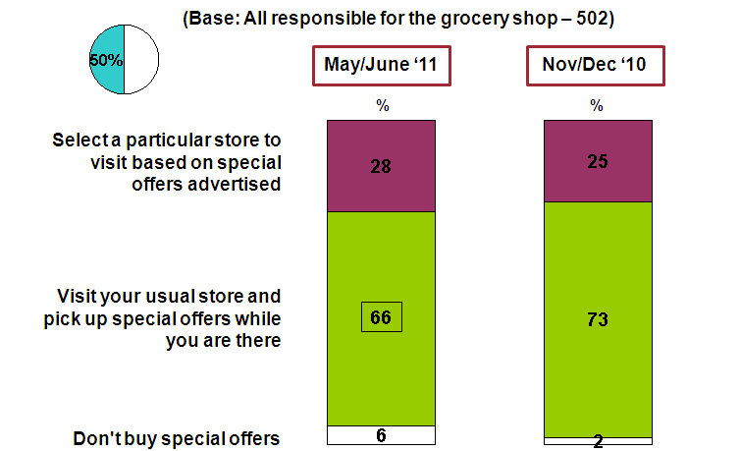

Key Points
In May and June 2011 the National Consumer Agency continued its programme of consumer research with a view to monitoring, analysing and recording patterns of consumer behaviour and experiences in Ireland. The research, consistent with previous surveys, was conducted by means of face-to-face interviewing with a nationally representative sample of 1,000 people between the ages of 15 to 74. This report presented the results relating to Irish consumers’ experience and attitudes with regard to shopping and pricing.

- 82% of consumers report that they shop around when purchasing goods and services, an increase of 11% since November/December 2010, the number that do not shop around has halved from 10% to 5%.
- Almost 3 in 4 consumers (74%) do not compare prices in relation to doctors, hospitals and other medical providers. 66% of consumers do not compare prices when purchasing from pharmacies.
- Over the last year there has been a significant increase in convenience as a key influencing factor in determining where to shop, up 10% percentage points to 23%, whereas price has fallen 19% points, from 72% in June 2010 to 53% at present.
- Over 4 in 5 (82%) check the price of products but consumers are less likely to check unit pricing with over 1 in 4 (28%) never doing so and less than 1 in 2 (47%) examining unit pricing sometimes or all the time.

In relation to grocery shopping:
- 4 in 5 (81%) shoppers now believe that you need to shop around in order to achieve the best value; 65% agree that the supermarket offering the best value for money changes week on week; 3 in 10 shoppers disagree that there is one supermarket that is cheaper than all the rest.
- Price remains the number one determining factor in deciding where to carry out the main grocery shop, although falling by 9% to 63%, with convenience considered the second most important factor, increasing by 5% to 54%.
- The average grocery shop now consists of 65% branded goods with the remaining 35% being own brand products.
- When purchasing own brand products, 37% of main grocery shoppers are primarily concerned with the quality of the product. The second biggest influencing factor as cited by 34% is price. For a fifth (19%) of shoppers, past experience of the product is most important.

The percentage changes mentioned in this report refer to an increase or decrease in percentage points.

