

National Consumer Agency

Market Research Findings:
Consumer Experiences with Direct Selling

August 2011
Table of Contents
1 Introduction and Methodology 4
2 Direct Selling 5
2.1 Door-to-Door Selling 5
2.2 Telephone Sales 8
3 Key Points 10

Table of Figures
Figure 1 Experience of Door-to-Door Selling 5
Figure 2 Categories of Product/Service Sold and Incidence of Signing-Up 6
Figure 3 Information Provided at the Door 7
Figure 4 Receipt of Cancellation Forms and Incidence of Expectations Fulfilled 7
Figure 5 Experience of Telephone Selling 8
Figure 6 Categories of Product/Service Sold and Incidence of Signing-Up 9
Figure 7 Information Provided in and Experience of the Telephone call 9

Introduction and Methodology
In May and June 2011 Amárach Research continued the programme of consumer research conducted by the National Consumer Agency to monitor, record and analyse patterns of consumer behaviour and experiences in Ireland.

The research, consistent with previous surveys, was conducted by means of face-to-face interviewing with 1,000 people between the ages of 15 to 74. To ensure that the data is nationally representative, quotas were applied on the basis of age, gender, social class and region. Interviews were conducted over a four-week period in May and June 2011.

The Agency’s rolling programme of market research explores a wide range of consumer behaviour and experiences in Ireland, including:
- The level of consumer empowerment, awareness of consumer rights and the propensity to complain
- Consumer behaviour with regard to shopping and pricing
- Consumers’ response to the recession and household budgeting
- Trends in switching goods/service providers and consumer experience with regard to direct selling

In addition to these recurring themes, the Agency routinely asks questions on topical consumer matters. In the latest iteration of the research, consumers were asked about their experiences of direct selling, both on the doorstep and by telephone. The findings of that research are set out in this short report.

PowerPoint versions of the slides in this report, in addition to details of all of the Agency’s research activities, are available from
http://www.nca.ie/eng/Research_Zone/Reports/.

Direct Selling
Consumers were asked about their experiences in relation to direct selling; specifically door-to-door and telephone sales.

Door-to-Door Selling

Overall 41% of consumers have experienced some form of door-to-door sales pitch. As illustrated in Figure 1, 35% of respondents have experienced someone calling to their door and trying to sell them a product or service, a similar proportion (34%) have experienced someone calling to their door and trying to get them to switch from a current product or service provider. According to more detailed data not shown, people living in Dublin have encountered a higher incidence of door-to-door selling than the national average.

- Experience of Door-to-Door Selling

As can be seen from Figure 2 of those who have experienced door-to-door selling, 4 in 5 (79%) have had someone from an energy provider call to their door, of which 3 in 10 actually purchased/switched. The next most common experience was of sales agents promoting telecommunications services, in this case over 2 in 5 (43%) had received calls with 18% purchasing/signing-up.

- Categories of Product/Service Sold and Incidence of Signing-Up

As depicted in Figure 3 below, just under 3 in 5 (57%) respondents who experienced door-to-door selling in the past 12 months were informed of their right to cancel any purchase made and just under 2 in 5 (39%) received written information on the product before signing-up. 57% felt that the offer was fully explained before signing-up, while 15% did not. Over 1 in 5 (21%) felt pressurised into signing-up for/purchasing the product or service.

- Information Provided at the Door

Of those who signed-up to a product or service provider, see Figure 4, just under 3 in 10 (29%) received a cancellation form. 84% of those who signed-up said that their expectations were met as the product or service purchased corresponded with what the salesperson had told them.

- Receipt of Cancellation Forms and Incidence of Expectations Fulfilled
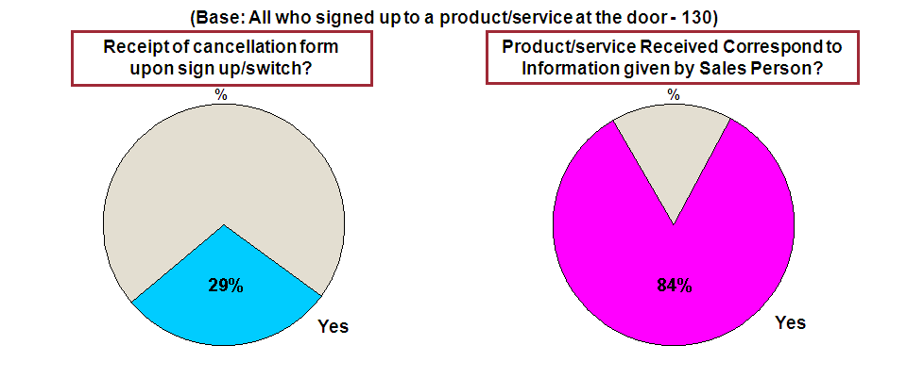

Telephone Sales

Overall 24% of respondents have experienced a telephone sales approach; as shown in Figure 5, 21% of respondents have received a telephone call from someone trying to sell a product or service and 20% have received a telephone call from someone trying to get them to switch from their current provider.

- Experience of Telephone Selling

As can be seen from Figure 6, of those who have experienced telephone sales, 3 in 4 (76%) had someone call from a telecommunications provider and of these, 12% signed-up to a product or service provider. The next most common category with 2 in 5 (40%) stating they had received a telephone sales call was in relation to energy suppliers where 10% of those contacted signed-up/purchased. The incidence of the consumer signing-up for the product/service on offer is substantially lower for telephone sales calls relative to door-to-door sales.

- Categories of Product/Service Sold and Incidence of Signing-Up

Just over 2 in 5 (42%) respondents, see Figure 7 below, who received a telephone sales call were informed of their right to cancel any purchase made. 43% felt that the offer was fully explained before signing-up, whilst 17% did not. 1 in 5 (20%) felt pressurised into signing-up for/purchasing the product or service.

- Information Provided in and Experience of the Telephone call

Key Points
In May and June 2011 the National Consumer Agency continued its programme of consumer research with a view to monitoring, analysing and recording patterns of consumer behaviour and experiences in Ireland. The research, consistent with previous surveys, was conducted by means of face-to-face interviewing with a nationally representative sample of 1,000 people between the ages of 15 to 74. This report presented the results relating to Irish consumers’ experience of door-to-door and telephone sales. The key findings are as follows:

- 41% of consumers have experienced some form of door-to-door sales pitch in the past 12 months, most likely from an energy supplier, 79%. Of this 79% a total of 30% of consumers signed-up to the service provider.

- Of those who signed up for a product or service at the doorstep just fewer than 3 in 5 (57%) received a cancellation form upon signing-up.

- Over 1 in 5 (21%) of those who experienced a door-to-door sales pitch felt pressurised into signing-up for/purchasing the product or service.

- 24% of respondents have experienced telephone selling in the past 12 months. 1 in 5 (20%) felt pressurised into signing up for/purchasing the product or service.

